
ff

Annual Investment Plan
  - June 2024
  - Australia’s Economic Accelerator Advisory Board


With the exception of the Commonwealth Coat of Arms, the department’s logo, any material protected by a trademark and where otherwise noted all material presented in this document is provided under a Creative Commons Attribution 4.0 International (https://creativecommons.org/licenses/by/4.0/) licence.
The details of the relevant licence conditions are available on the Creative Commons website (accessible using the links provided) as is the full legal code for the CC BY 4.0 International (https://creativecommons.org/licenses/by/4.0/legalcode)
The document must be attributed as the AEA Annual Investment Plan 2024-25.

Contents
Foreword 4
Introduction 5
Purpose of the Investment Plan 6
Stages 6
Funding available 7
Participation 7
AEA Investment Priorities 8
Areas of national priority 8
AEA focus areas 9
Approach 9
Identified focus areas 9
Future work 12
Appendix – AEA Focus Area Profiles 13

Foreword
As the inaugural Chair of the Australia’s Economic Accelerator (AEA) Advisory Board. I am pleased to present the first AEA program investment plan for 2024-2025.
This plan provides early and critical guidance, informed by the experience and expertise of the Board, broader Government economic priorities such as the Future Made in Australia agenda and the National Reconstruction Fund, as well as the lessons gleaned from the initial pilot rounds of AEA and consultation with industry and the university research sector. The plan will ensure that the AEA program meets its objective of supporting research in areas of national priority to progress the development of technologies and services to a state of commercial investor readiness.
A key feature of this first investment plan is that the Board has determined priorities for the upcoming grant rounds. These focus areas have been identified through extensive engagement and have been selected to provide translation opportunities for the Australian research sector going forward.
The members of the AEA Advisory Board believe that the identified focus areas will help guide the university sector in selecting projects and industry partners that will support and further their research to achieve mutually beneficial translation and commercialisation goals.
Into the future the AEA Advisory Board will continue to work with the research sector and across industry to identify and align focus areas to benefit the ultimate goal of a stronger research commercialisation and translation capability at a national level.
Yours sincerely

Mr Jeff Connolly
Chair of the AEA Advisory Board

Introduction
Australia’s Economic Accelerator (AEA) is a new research funding program designed to shift the dial on Australian research by supporting the translation and commercialisation of our world leading research in the university sector. The program is supporting a culture shift to improve collaboration between universities and industry to commercialise university research in areas where Australia has strong competitive advantage and that solves domestic and global market needs.
The AEA is one of a suite of programs that will help create a research ecosystem where our
world-class research is translated into innovations to serve real world market needs and deliver productivity and economic gains. The objectives of the AEA, the Trailblazer Universities Program and the National Industry PhD program align with the Australian Government’s Future Made in Australia agenda.
As a priority-driven grant program, AEA will support projects aligned with national research priorities with high commercial opportunity. Funding is available to universities, and applicants will partner with industry.
The AEA is designed to attract projects at a proof-of-concept or proof-of-scale level of commercial readiness that have high commercial potential (Figure 1). Projects can come into the program at any stage or progress through the program, based on continued success and achievement of milestones that validate the commercial potential and path to commercial product. To incentivise ongoing excellence, the amount of AEA funding increases as projects mature towards at-scale commercialisation.
The expanded Main Sequence Ventures fund provides a high-value opportunity for projects that successfully progress through the AEA. Alternatively, outcomes from the AEA can be picked up by businesses who can take them further on the path to commercialisation or by other sources of financing such as venture capital investment, including through other initiatives such as the Clean Energy Finance Corporation and the National Reconstruction Fund (NRF).
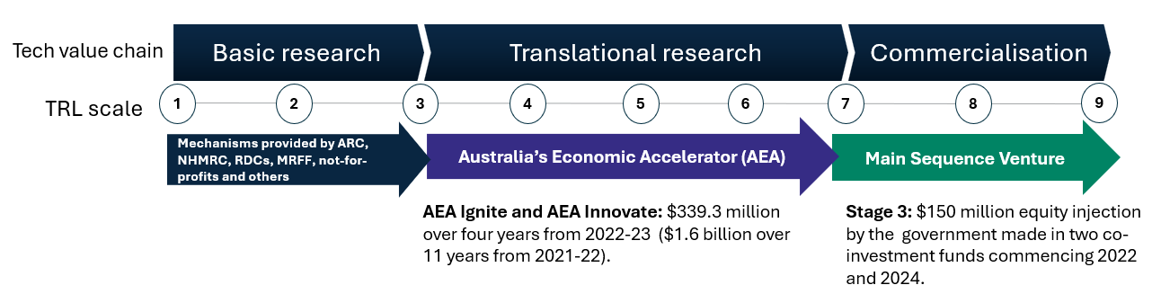
Industry participation is critical to the success of the program. Examples of industry involvement include embedded industry experts, in-kind support, formal collaborations or partnerships, and investment.
Figure 1. The AEA is designed to bridge the gap between basic research and commercialisation.
The AEA is governed by an expert Advisory Board (the Board), supported by expert Priority Managers. The Board members have experience and knowledge in research and its translation and commercialisation, and represent government, industry and research sectors. The Priority Managers are highly qualified, experienced, and motivated business and technology specialists. The Priority Managers will work with successful applicants to help foster connections and secure formal collaboration arrangements with industry partners.
Distinct from other funding models in research, the AEA Program will support the translation and commercialisation of the outcomes of university research in collaboration and partnership with industry. It will fill a gap in the current research commercialisation landscape by funding the university sector to engage in translational research from early-stage research into products that are attractive for industry collaboration and investment and will have impact in major markets and grow Australia’s economy.

Purpose of the Investment Plan
AEA delivery
The AEA program will be administered by the Department of Education with the assistance of the Board whose members are appointed by the Minister. The Board’s functions are stipulated under Section 42-15 of HESA.

Stages
AEA grants will be delivered through the 2 streams (Figure 2). These distinct streams are targeted at different stages of technology readiness (TRL).

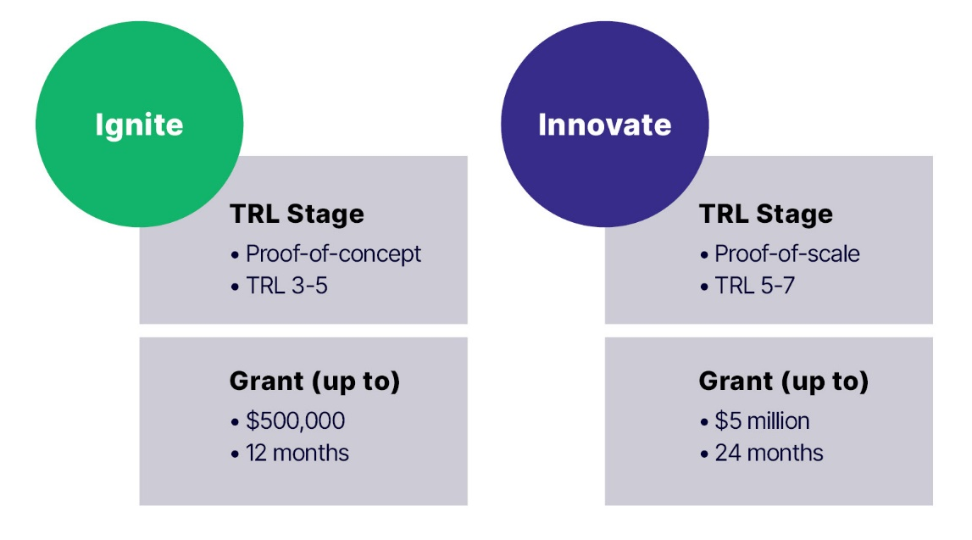
Figure 2. AEA grants are provided through 2 funding streams targeted at different stages of the technology value chain.

Funding available
To address anticipated strong initial demand for AEA grants, Round 1 of Ignite grants will have an allocation of $60 million and Round 1 of Innovate grants will have an allocation of $120 million. These will be followed by Round 2 of Ignite with an allocation of $30 million and Round 2 of Innovate with an allocation of $60 million. The expected ongoing cadence of the program will then be 2 rounds each per year for Ignite and Innovate.
For each round, the total funding to be awarded through grants as well as the relative funding against different priority areas will be driven by the quality of applications received. The above allocations will only be exhausted where enough applications of sufficient quality, as deemed by expert assessors and the AEA Board, are received.
The Board will review AEA funding available in the context of its next annual investment plan.

Participation
As part of the AEA program’s commitment to helping uplift research translation and commercialisation activity on a national scale, AEA grant applicants will be asked to address how their project includes researchers from diverse backgrounds. These include and are not limited to female identified entrepreneurs or researchers, First Nations entrepreneurs, and researchers from regionally headquartered institutions.
Based on learnings from the AEA Seed pilot program, applications received from regionally headquartered universities (and other universities partnering with these), female identified Lead Entrepreneurs and First Nations identified Lead Entrepreneurs to Round 1 of Ignite will be eligible to receive additional points after assessment and benchmarking of their application.

AEA Investment Priorities

Areas of national priority
The AEA serves a vital role in Australia’s research and innovation landscape by providing the support necessary to accelerate research outputs into a state of investor readiness. Therefore, it is critical that efforts are targeted to areas where Australian research can build scale and have real-world impact.
On this basis, the AEA will:
- aim to deliver innovations that leverage Australia’s natural and comparative advantages in areas of strategic importance
- support research translation and commercialisation that is aligned with the government identified priority areas of the economy (outlined in the National Reconstruction Fund Corporation (Priority Areas) Declaration 2023):
  - value-add in resources
  - value-add in agriculture, forestry and fisheries
  - transport
  - medical science
  - renewables and low emissions technologies
  - defence capability
  - enabling capabilities (that have the potential to diversify and transform Australian industry across a number of sectors).
- ensure ongoing planning and investment remains aligned with related activities, such as the co-investment plans being developed across the above priority areas of the economy
- complement industry targeted initiatives to enhance innovation and expand domestic manufacturing, including the NRF and the Industry Growth Program
- support other key Government policy objectives such as sovereign capability needs, circular economy and net zero commitments.
The AEA will also support objectives of the Government’s Future Made in Australia agenda, including research and commercialisation aligned with the initial priority sectors the Government has identified as part of its Future Made in Australia agenda, including:
- renewable hydrogen
- critical minerals processing
- green metals
- low carbon liquid fuels
- clean energy manufacturing, including battery and solar panel supply chains.
To ensure AEA investment drives the best possible outcomes, the Board has identified focus areas within the above areas of national priority to be prioritised for AEA funding. This is consistent with the requirement in HESA to set out detailed and specific advice on investment opportunities for the AEA in areas of national priority.

AEA focus areas
To support AEA investment planning, the Board has considered focus areas where the AEA program can make strong contributions to rebuilding, modernising, and diversifying Australia’s industry base and economy.
A shared focus and sense of problem, across the research and innovation community is a key step in driving stronger partnerships and better outcomes in areas where Australia can leverage its advantages to develop future industries. The identification of AEA focus areas (and research translation needs within each of these areas) is designed to provide the Australian research community with clear targets against which to apply their expertise, capacity and talent. Accordingly, when considering proposals, the AEA will first examine whether projects are addressing a genuine need before considering the capacity and capability of proponents to deliver it.
The focus areas presented here will help ensure that proposals received from researchers are responding to genuine national needs and opportunities.

Approach
To inform the identification of AEA investment priorities, the Board has:
- considered areas of potential future growth where there is high quality research with high potential for translation but where translation outcomes are below international benchmarks
- taken into account global and domestic market opportunities, the research landscape, the capacity to translate research, and alignment to national policy priorities
  - focused both on assessing where Australia has a base level of research strength and capacity, as well as significant potential to improve our research translation performance to support key national priorities
  - considered input from industry, research, and government experts.

Identified focus areas
On this basis, the Board has identified 6 focus areas that will be prioritised for investment in AEA grant rounds opened under this Investment Plan. These are outlined below with further information on the supporting data in the Appendix.
Some of the identified focus areas represent established or emerging sectors within areas of national priority where there is strong potential for AEA investment to deliver impact. Others represent transformative and advanced platform technologies that can drive cross-sectoral productivity (enabling capabilities). This diverse approach aims to build a portfolio of AEA investments over time that will leverage the most promising technologies to deliver internationally competitive industrial capability in sectors of national importance.
These 6 focus areas directly contribute towards areas of national priority and will capitalise on important opportunities in areas of Australian economic advantage, such as refining and processing of critical minerals, renewable hydrogen, and green metals. The quantum technologies, artificial intelligence, and advanced manufacturing AEA focus areas will deliver enabling capabilities with cross-sectoral application across all Government identified priority areas of the economy.

These areas were selected from a broader list of opportunities derived through a scan of policy documents, strategies, roadmaps, and national priorities or missions, consideration of domestic and international technology foresighting frameworks, and analysis of associated data. It is important to note that these 6 focus areas do not represent an end state. Given the increasingly interdisciplinary nature of modern research and rapidly changing nature of the technological landscape, ongoing monitoring and evaluation of future opportunities will be undertaken by the Board to ensure the program is responsive to developments in the research and industry sectors.

AEA Focus Areas (2024-25)

Critical and strategic minerals processing
(supports the value-add in resources government identified priority area)
Technologies which enable the transition from mineral to material, namely processing and early value chain manufacturing techniques utilising mineral inputs deemed critical or strategic to the national interest. This includes technologies to enable exploration, low environmental impact extraction and processing of minerals, especially those needed for the energy transition like copper, new and sustainable value-add opportunities in green metals, novel and high purity refining methods for minerals like lithium and silicon, and other technologies to improve mineral recovery and processing efficiency.
Sustainable fuels
(supports the renewables and low emissions technologies, transport and value-add in agriculture, forestry and fisheries government identified priority areas)
Renewable energy carriers and fuels for transport and industrial uses which present sustainability benefits (primarily, quantifiable emissions reductions) when compared to traditional sources. This includes particular focus on the production of renewable hydrogen and low carbon liquid fuels (including synthetic fuels such as drop-in sustainable aviation fuel (SAF) and production using existing waste streams), as well as innovations in the transport, storage, and industrial applications of these fuels, including in the processing of green metals.
Digital agriculture
(supports the value-add in agriculture, forestry and fisheries government identified priority area)
Applications of digital platforms and data-driven approaches such as Internet of Things (IoT) and precision agriculture, automation and robotics, prediction and modelling, remote observation and mapping, and other novel methods to increase value-add, optimise resource usage, and enhance Australia’s already outstanding reputation for producing safe and high-quality agricultural and food products.
Enabling capabilities
(supports the enabling capabilities government identified priority area and have the potential to diversify and transform Australian industry across a number of sectors)
Quantum
Technologies which make downstream use of quantum physics principles to deliver innovations in sensing and measurement, positioning and timing, quantum communication and cryptography capabilities, and progress toward industry-ready quantum computation.
Artificial intelligence
Technologies which enable autonomous systems to solve problems and complete complex tasks such as prediction and object detection, with an initial focus on language processing, computer vision and support for robotics.
Advanced manufacturing
Technologies which expand Australia’s capability to manufacture complex products. It includes novel materials such as advanced composites as well as equipment and processes, novel additive manufacturing processes, capabilities to produce critical goods like semiconductors and integrated circuits, and materials that use critical and strategic minerals.

Future work
Each year, as Australia’s research and development (R&D) landscape and national priorities evolve, the Board will advise on changes necessary to match quality research with industry demand and capture emerging technology and innovation opportunities.
Consistent with the Australian Government’s Future Made in Australia ambition, this approach will ensure AEA investment remains targeted over time in areas where Australia has comparative advantage and the highest likelihood of delivering real impact for Australian industry and the public.
In preparation for the next Investment Plan, the Board will continue to:
  - examine AEA focus areas that represent opportunities for research translation and commercialisation and align with Australia’s strengths and potential markets
  - investigate ways of boosting participation of researchers with diverse backgrounds (including from regionally headquartered universities, female identified researchers and First Nations identified researchers)
  - Priority managers will engage with potential industry partners to identify tangible problems that AEA investment could help address.

Appendix – AEA Focus Area Profiles




Critical & Strategic Minerals Processing

Australia’s Economic Accelerator (AEA) is a $1.6 billion Australian Government investment aimed at transforming Australia’s research translation and commercialisation landscape. AEA grants support the Australian Government identified priority areas for the economy (outlined in the National Reconstruction Fund Corporation (Priority Areas) Declaration 2023). Within these priorities, the first round of grants will prioritise projects that align with one or more of 6 focus areas, including advanced manufacturing, artificial intelligence, digital agriculture, quantum, sustainable fuels, and critical and strategic minerals processing.
Critical and strategic minerals processing are technologies enabling the transition from mineral to material, namely processing and early value chain manufacturing techniques using mineral inputs deemed critical or strategic to the national interest. This includes technologies to enable exploration, low environmental impact extraction and processing of minerals that are vital for the energy transition like copper; new and sustainable value-add opportunities in green metals; novel and high purity refining method or minerals like lithium; and other technologies to improve mineral recovery and processing efficiency.

National priority
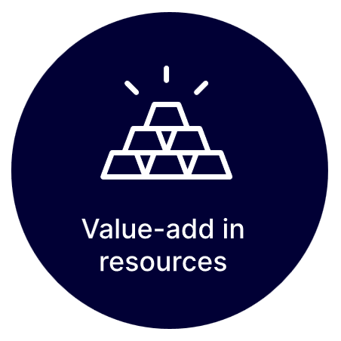 | Strong policy priority that aligns with our resource advantage and feeds into other priority sectors. Critical and strategic minerals processing aligns with the national priority areas through adding value to extracted goods and the building of onshore industrial capability.  - Critical Minerals Strategy 2023-2030  - List of Critical Technologies in the National Interest  - Future Made in Australia agenda
Advantage | Opportunity
Australia possesses a diverse and rich mineral endowment and is a significant exporter of multiple critical and strategic mineral classes. | To utilise our mineral endowment and competitive energy factor costs to reduce sovereign risks and realise more value from growing global demand.

Research strength

Australia’s rank in the OECD calculated using 2018-2022 bibliometric data from Elsevier’s SciVal. Critical & strategic minerals processing was defined using custom search terms.

10th – Output: number of scholarly papers

1st – Impact: field-weighted citation impact
1st – Quality: amount of papers in 10% most cited journal


IP potential
91%
Australia’s share of publications cited in patent applications compared to the OECD average expressed as a percentage.
Refers to 2018-2022 patent and publication data in the Lens database.

Market opportunity assessment
- Australian market size of AU$56 billion in 2023
- Projected compound annual market growth of 13.8% from 2018-23
- Projected global market size of AU$465 billion in 2022

Example industry problems
AEA aims to provide developmental support for promising research commercialisation projects at the proof-of-concept or proof-of-scale level (TRL stages 3-7). Successful projects will scale up to meet emerging industry needs.
Industry problem | Opportunity | Impact
Net zero minerals processing equipment and techniques remain relatively high cost. | Development of cost-competitive clean processing methods (e.g. using electric arc furnaces and hydrogen or retro-fitting existing facilities). | Supports the growth of a domestic processing industry which leverages Australia’s renewable energy advantage.
Useful by-products in mineral processing streams are currently being under-utilised, resulting in significant waste and environmental impact. | Developing methods for extracting additional mineral products from existing processing streams (e.g. gallium from bauxite) and minimising waste. | Increase the diversity of critical and strategic minerals which can be produced from existing processes whilst reducing environmental impact.
A large amount of exploration related data remains under-utilised, including in the creation of exploration models to improve drilling productivity. | Developing a variety of means to interpret data (i.e. creation of models using AI) so new data is better interpreted and exploration/ extraction methods improved. | Higher certainty based on better data interpretation could improve greenfield profitability.
More effective mine site automation is required to encompass more processes. | To extend automation to include ore extraction, transport, crushing, concentration, and in some cases purification. | Improved autonomous processes will not only improve productivity, reduce harm to operators and environment, but also help meet ESG targets more competitively.
Domestic production of solar cells and other energy transition products requires a cost-competitive and resilient supply chain for silicon. | Developing cost-competitive and clean methods for the smelting of silicon, alongside production of polysilicates and early-stage value-add products like wafers and ingots. | Facilitate the growth of a resilient domestic supply chain for input minerals into key energy transition products while meeting growing global demand.

Other public investment options
- ARENA and the Future Made in Australia Innovation Fund
- The National Reconstruction Fund
- Export Finance Australia & the Critical Minerals Facility

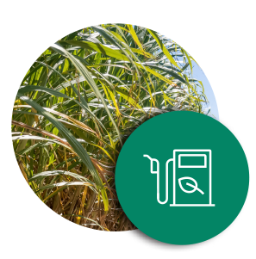

Sustainable Fuels

Australia’s Economic Accelerator (AEA) is a $1.6 billion Australian Government investment aimed at transforming Australia’s research translation and commercialisation landscape. AEA grants support the Australian Government identified priority areas for the economy (outlined in the National Reconstruction Fund Corporation (Priority Areas) Declaration 2023). Within these priorities, the first round of grants will prioritise projects that align with one or more of 6 focus areas, including advanced manufacturing, artificial intelligence, digital agriculture, quantum, sustainable fuels, and critical and strategic minerals processing.

Sustainable fuels are renewable energy carriers and fuels for transport and industrial uses which present sustainability benefits (primarily, quantifiable emissions reductions) when compared to traditional sources. This includes particular focus on the production of renewable hydrogen and low carbon liquid fuels (including synthetic fuels such as drop-in sustainable aviation fuel (SAF) and production using existing waste streams). As well as innovations in the transport, storage, and industrial applications of these fuels, including in the processing of green metals.

National priority
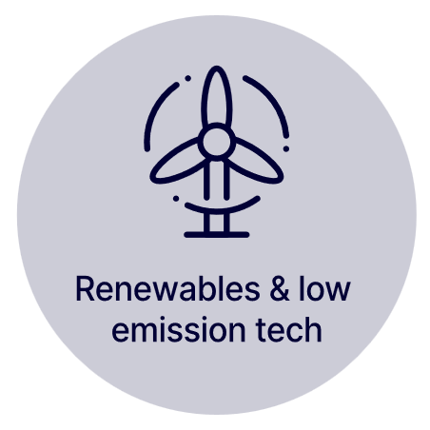     | Strong policy priority that aligns with Australia’s resource advantage and feeds into other priority sectors. Sustainable fuels align with the national priority areas as an opportunity to capitalise on domestic and global energy trends and support realisation of net zero emissions targets.  - National Hydrogen Strategy  - List of Critical Technologies in the National Interest  - Hydrogen Headstart program

Advantage | Opportunity
Australia possesses strong renewable energy resources and a wide range of feedstocks for alternative fuel chemistries alongside existing conventional infrastructure and industry capability. | Build domestic sustainable fuel and hydrogen industries which can support decarbonisation of hard-to-abate sectors while capturing value from the global energy transition.

Research strength
Australia’s rank in the OECD calculated using 2018-2022 bibliometric data from Elsevier’s SciVal.
Sustainable fuels was defined using custom search terms.
8th – Output: number of scholarly papers
1st – Impact: field-weighted citation impact
6th – Quality: amount of papers in 10% most cited journal


IP potential
94%
Australia’s share of publications cited in patent applications compared to the OECD average expressed as a percentage.
Refers to 2018-2022 patent and publication data in the Lens database.

Market opportunity assessment
- Australian market size of AU$1.6 billion in 2022
- Projected compound annual market growth of 23% from 2022-2030
- Global market size of AU$476 billion in 2023
- Projected global compound annual market growth of 9.1% from 2023-2028

Example industry problems
AEA aims to provide developmental support for promising research commercialisation projects at the proof-of-concept or proof-of-scale level (TRL stages 3-7). Successful projects will scale up to meet emerging industry needs.
Industry problem | Opportunity | Impact
Industrial transport (long-range aviation, heavy road transport, shipping and rail) comprises 44% of total Australian transport emissions. They require power and range capabilities that are not attainable through electrification in the short term. | Produce cost-competitive drop-in biofuels and synthetic fuels at a scale that can reduce emissions trajectories from these sectors in the medium term. | Immediate emissions reduction in long-range industrial transport (including aviation) and opportunity to grow an industry from waste.
Australia has a limited supply of biofuel and synthetic fuel feedstocks, which may increase their cost. However, to be viable, biofuels must sell at parity or less than fossil fuels. | Develop novel conversion processes or feedstock enhancements that optimise the energy density of clean biofuels, whilst reducing costs and achieving commercial viability at scale. | Support scale up and sustainability (lower emissions and commercial viability) of a new biorefining industry.
The storage, transport and handling of hydrogen requires infrastructural renewal, components and novel interoperability solutions. | Pioneer commercially viable systems to safely store, transport and handle renewable hydrogen at scale. | Improve the commercial viability of renewable hydrogen to accelerate scaleup.
Generating 1 kilogram of green hydrogen through electrolysis uses 15 to 20 kilograms of clean water. | Develop solutions to reduce the demand for clean water, such as through advanced electrolysis and fuel cells and processing alternate water inputs. | Improve social licence and commercial viability of renewable hydrogen to accelerate uptake.

Other public investment options
- ARENA & the Future Made in Australia Innovation Fund
- Industry Growth Program
- Clean Energy Finance Corporation
- The National Reconstruction Fund
- Hydrogen Headstart Program
- Future Made in Australia Hydrogen Production Tax Incentive
- Rural Research and Development Corporation


Digital Agriculture

Australia’s Economic Accelerator (AEA) is a $1.6 billion Australian Government investment aimed at transforming Australia’s research translation and commercialisation landscape. AEA grants support the Australian Government identified priority areas for the economy (outlined in the National Reconstruction Fund Corporation (Priority Areas) Declaration 2023). Within these priorities, the first round of grants will prioritise projects that align with one or more of 6 focus areas, including advanced manufacturing, artificial intelligence, digital agriculture, quantum, sustainable fuels, and critical and strategic minerals processing.
Digital agriculture includes applications of digital platforms and data-driven approaches such as Internet of Things (IoT) and precision agriculture, automation and robotics, prediction and modelling, remote observation and mapping, and other novel methods to increase value-add, optimise resource usage, and enhance Australia’s already outstanding reputation for producing safe and high-quality agricultural and food products.

National priority
Agriculture is a key export sector drawing on Australia’s resource advantage and where technology driven productivity gains are particularly impactful. Digital agriculture aligns with the national priority areas through supporting development of sustainable processes and advanced technology across agriculture, forestry, and fishery value chains.
- Agricultural Traceability Strategy 2023-2033
- Agriculture and Land Sectoral Plan
- On Farm Connectivity Program
- Future Drought Fund
- List of Critical Technologies in the National Interest
Advantage | Opportunity
Australia is a trusted exporter of a wide range of agricultural products and a major supplier for growing global markets. | To increase agricultural productivity and value-add while expanding Australia’s trusted brand into new markets and supporting sustainability and conservation goals.

Research strength
Australia’s rank in the OECD calculated using 2018-2022 bibliometric data from Elsevier’s SciVal. Digital agriculture was defined using custom search terms
6th – Output: number of scholarly papers
4th – Impact: field-weighted citation impact
2nd – Quality: amount of papers in 10% most cited journal


IP potential
97%
Australia’s share of publications cited in patent applications compared to the OECD average expressed as a percentage.
Refers to 2018-2022 patent and publication data in the Lens database.

Market opportunity assessment
- Australian market size of AU$12.4 billion in 2020
- Predicted compound annual market growth of 18.4% from 2020-2026
- Global market size of AU$31 billion in 2024
- Predicted global compound annual growth rate of 10.5% from 2024-2029

Example industry problems
AEA aims to provide developmental support for promising research commercialisation projects at the proof-of-concept or proof-of-scale level (TRL stages 3-7). Successful projects will scale up to meet emerging industry needs.
Industry problem | Opportunity | Impact
New consumer and trade partner demands for origin and sustainability information on products requires new levels of traceability. | Development of systems or tools for guaranteeing product characteristics and origin; and for tracing and optimising agricultural supply chains. | Bolstering Australia’s global reputation as a high-quality producer of agricultural products and capitalising on emerging consumer markets.
Labour shortages and relatively high labour costs increase the volatility and decrease the competitiveness of some Australian agricultural products. | Applying precision agriculture and physical automation systems to offset labour costs and increase productivity in areas such as harvest or post-harvest processing. | Reduce dependence on volatile labour flows and increase the competitiveness of Australia’s agricultural products.
Climate change and general environmental volatility present risks to the viability of core agricultural products, particularly in the crop and horticulture sectors. | Applying sensors and IoT solutions to enable adaptive intervention and detailed monitoring for crops, including in areas like irrigation and soil health. | Reduce the impact of a volatile climate on Australia’s agricultural output and mitigate against loss and damage and any resultant disruptions to trade.

Other public investment options
• Agricultural Traceability Grants
• The National Reconstruction Fund
• Industry Growth Program
• Rural Research and Development Corporations


Quantum

Australia’s Economic Accelerator (AEA) is a $1.6 billion Australian Government investment aimed at transforming Australia’s research translation and commercialisation landscape. AEA grants support the Australian Government identified priority areas for the economy (outlined in the National Reconstruction Fund Corporation (Priority Areas) Declaration 2023). Within these priorities, the first round of grants will prioritise projects that align with one or more of 6 focus areas, including advanced manufacturing, artificial intelligence, digital agriculture, quantum, sustainable fuels, and critical and strategic minerals processing.
Quantum technologies make downstream use of quantum physics principles to deliver innovations in sensing and measurement, positioning and timing, quantum communication and cryptography capabilities, and progress towards industry-ready quantum computation.

National priority
 | Quantum technologies require considered and timely investment in research and commercialisation to seize the economic and strategic opportunities that they present. Quantum aligns with the national priority areas through support for transformative technologies that drive cross-sectoral productivity.  - National Quantum Strategy  - List of Critical Technologies in the National Interest  - Future Made in Australia agenda  - National Defence Strategy

Advantage | Opportunity
Australia hosts world-leading research and early-stage commercialisation activity in quantum technologies and is endowed with key input materials for quantum components and goods. | Capitalise on an early-mover advantage to capture a share of the emerging global quantum technologies market and realise productivity and enabling benefits across domestic industries.

Research strength
Australia’s rank in the OECD calculated using 2018-2022 bibliometric data from Elsevier’s SciVal. Quantum was defined using the Field of Research (FoR) code 5108 – Quantum Physics.
11th – Output: number of scholarly papers
6th – Impact: field-weighted citation impact
1st – Quality: amount of papers in 10% most cited journal


IP potential
127%
Australia’s share of publications cited in patent applications compared to the OECD average expressed as a percentage.
Refers to 2018-2022 patent and publication data in the Lens database.

Market opportunity assessment
- Australian market size of AU$0.2 billion in 2023
- Projected compound annual market growth of 31.9% from 2023-2028
- Global market size of AU$1.5 billion in 2022
- Projected global compound annual market growth of 40% from 2022-2030

Example industry problems
AEA aims to provide developmental support for promising research commercialisation projects at the proof-of-concept or proof-of-scale level (TRL stages 3-7). Successful projects will scale up to meet emerging industry needs.
Industry problem | Opportunity | Impact
Lack of effective solutions for precision navigation in GPS-denied environments (e.g., subterranean, sub-sea, or space). | Developing GPS-free positioning devices using quantum principles and applying them to vehicle platforms and space. | Accurate and robust positioning for spacecrafts and vehicles in mining, maritime, space and defence applications.
Adapting to the risks for agriculture from increasing climate uncertainty and extreme weather events. | Using quantum computing techniques to more accurately model and forecast complex systems like climate and weather. | Greater resilience and efficiency for agricultural producers.
Conventional computing approaches struggle to accurately model complex molecular interactions. | Developing quantum software and hardware solutions for chemical and molecular modelling to apply to pharmaceutical, energy, and other industries. | Widen the aperture on possibilities in chemical synthesis and drug design and increase the speed of research and development pipelines that rely on computationally intensive modelling.

Other public investment options
• The National Reconstruction Fund
• Industry Growth Program
• Advanced Strategic Capabilities Accelerator (Department of Defence)
• Critical Technologies Challenge Program
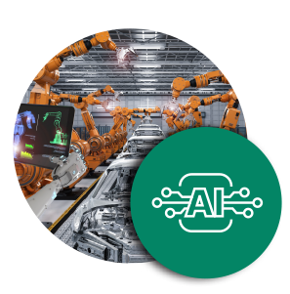

Artificial Intelligence

Australia’s Economic Accelerator (AEA) is a $1.6 billion Australian Government investment aimed at transforming Australia’s research translation and commercialisation landscape. AEA grants support the Australian Government identified priority areas for the economy (National Reconstruction Fund Corporation (Priority Areas) Declaration 2023). Within these priorities, the first round of grants will prioritise projects that align with one or more of 6 focus areas, including advanced manufacturing, artificial intelligence (AI), digital agriculture, quantum, sustainable fuels, and critical and strategic minerals processing.
AI encompasses technologies that enable autonomous systems to solve problems and complete complex tasks such as prediction and object detection, with an initial focus on language processing, computer vision and support for robotics.

National priority
Fast-moving enabling technology area with considerable benefits to early-mover adoption and investment. AI aligns with the national priority areas by supporting commercialisation of transformative advanced technologies that drive cross-sectoral productivity and support national interests.
- List of Critical Technologies in the National Interest
Advantage | Opportunity
Australia possesses strong AI research capability alongside diverse, secure, and unique sources of data with significant downstream industry demand for AI tools. | To apply existing research capability to uplift general productivity and produce application specific AI products that can support industries and scale up and out internationally.

Research strength
Australia’s rank in the OECD calculated using 2018-2022 bibliometric data from Elsevier’s SciVal. AI was defined using custom search terms.
7th – Output: number of scholarly papers
2nd – Impact: field-weighted citation impact
1st – Quality: amount of papers in 10% most cited journal


IP potential
95%
Australia’s share of publications cited in patent applications compared to the OECD average expressed as a percentage.
Refers to 2018-2022 patent and publication data in the Lens database.

Market opportunity assessment
- Australian market size of AU$2.5 billion in 2024
- Predicted compound annual market growth of 13.4% from 2024-2029
- Global market size of AU$118 billion in 2022
- Predicted global compound annual market growth of 21.4% from 2022-2030

Example industry problems
AEA aims to provide developmental support for promising research commercialisation projects at the proof-of-concept or proof-of-scale level (TRL stages 3-7). Successful projects will scale up to meet emerging industry needs.
Industry problem | Opportunity | Impact
Expanding demand for sustainable critical mineral extraction requires new and precise mineral discovery methods. | Developing AI tools to accelerate discovery and location of mineral deposits using existing geoscientific and mining data | Add value to pre-existing data resources and enable efficient expansion of critical mineral industries.
Land and asset management is costly and time-consuming, particularly in remote areas and for industries with geographically dispersed assets. | Utilise computer vision and image classification techniques to enable satellite, drones or other platforms to conduct inspections and assess conditions or detect faults. | Expand capability to monitor vast areas and dispersed assets, with an added sovereign capability for conservation, disaster response, and defensive monitoring.
Demographic pressures and demands for new forms of care (e.g. mental health) require new modes of service delivery. | Development of AI tools to improve the delivery of frontline services, enable remote care, and improve the efficiency of support services. | Impacts could include a reduction in delivery costs and/or improved health outcomes delivered sooner.
Developments in AI both challenge and assist cybersecurity objectives across numerous areas including defence, financial services and telecommunications. | Developing software and product solutions that can make use of or counteract AI to maintain cyber assets, as well as hardware with AI on-device or in the cloud to improve performance. | Counteract existing and emerging risks of financial fraud, identity theft, social engineering and data breaches, and protect sovereign IP and data assets.

Other public investment options
- ARENA & the Future Made in Australia Innovation Fund
- Industry Growth Program
- The National Reconstruction Fund


Advanced Manufacturing

Australia’s Economic Accelerator (AEA) is a $1.6 billion Australian Government investment aimed at transforming Australia’s research translation and commercialisation landscape. AEA grants support the Australian Government identified priority areas for the economy (outlined in the National Reconstruction Fund Corporation (Priority Areas) Declaration 2023). Within these priorities, the first round of grants will prioritise projects that align with one or more of 6 focus areas, including advanced manufacturing, artificial intelligence, digital agriculture, quantum, sustainable fuels, and critical and strategic minerals processing.

Advanced manufacturing refers to technologies that expand Australia’s capability to manufacture complex products. It includes novel materials such as advanced composites as well as equipment and processes, novel additive manufacturing processes, capabilities to produce critical goods like semiconductors and integrated circuits, and materials that use critical and strategic minerals.

National priority
Technology area that enables development of more complex domestic manufacturing industries and strengthening of Australia’s sovereign capability. Advanced manufacturing aligns with national priority areas by supporting commercialisation of transformative advanced technologies that drive cross-sectoral productivity and support national interests.

- Critical Minerals Strategy 2023-2030
- List of Critical Technologies in the National Interest
- Future Made in Australia agenda
Advantage | Opportunity
Australia has access to a diverse set of input materials and minerals, a highly skilled workforce, and hosts world-leading research with unrealised industrial potential. | To add value to our existing material inputs and develop sovereign capability to produce complex goods that feed into Australia’s industries and command greater value in global supply chains.

Research strength
Australia’s rank in the OECD calculated using 2018-2022 bibliometric data from Elsevier’s SciVal. Advanced manufacturing was defined using custom search terms.
8th – Output: number of scholarly papers
1st – Impact: field-weighted citation impact
1st – Quality: amount of papers in 10% most cited journal


IP potential
97%
Australia’s share of publications cited in patent applications compared to the OECD average expressed as a percentage.
Refers to 2018-2022 patent and publication data in the Lens database.

Market opportunity assessment
- Australian additive manufacturing market size of AU$0.11 billion in 2022
- Projected compound annual market growth of 23.3% from 2023-2030
- Global market size of AU$19.6 billion in 2022
- Projected global compound annual market growth 20.4% in 2022-2030

Example industry problems
AEA aims to provide developmental support for promising research commercialisation projects at the proof-of-concept or proof-of-scale level (TRL stages 3-7). Successful projects will scale up to meet emerging industry needs.
Industry problem | Opportunity | Impact
High complexity input goods like semiconductors and integrated circuits face supply risks. | Build Australian capability to produce highly specialised semiconductors or gain more value from our raw materials used in their production. | Reduce the impact of trade shocks and gain a stake in the growing market for highly complex electronic components.
Industries with large depleting capital stock or vehicle fleets face high maintenance and capital upgrading costs over time. | Develop more advanced techniques and equipment for in-situ or low-cost manufacturing of complex parts, including additive manufacturing and feedstock materials like powders. | Reduce costs for the maintenance of assets in Australia’s core industries and reduce reliance on external sources.
Complex and personalised therapeutics require higher speed and output production methods to scale up and become affordable. | Develop innovations that support high throughput methods to produce higher volumes of diverse pharmaceutical products. | Expand availability of novel therapeutics and medicines across Australia and support the development of domestic pharmaceuticals manufacturing.
Metal powders for additive manufacturing, (3D printing, thermal and cold spray coating) are all imported and expensive. Prices can be over $100 per kilogram and up to $3,000 per kilogram. | Create locally deployable processes to produce additive manufacturing inputs and/or improvements to existing processes (e.g. particle size and geometry optimisation for the CSIRO titanium powder from ore (TIRO) process). | Enable more cost-effective additive manufacturing with consistent quality through local supply chains.
Coatings for improving wear and corrosion resistance. | Develop technologies to employ newly developed materials with superior properties such as high-entropy alloys in additive manufacturing processes. | Improved lifetimes and reduced maintenance for infrastructure and equipment in demanding environments.
Space infrastructure components face high risk of component failure due to factors such as thermal intolerance. | Leveraging Australia’s additive manufacturing capability to build more efficient and reliable components for space infrastructure and systems. | Rapid and precise manufacture of reliable and tolerant components for the space industry while also helping to expand Australia’s intelligence, surveillance, reconnaissance, and climate observation capabilities.

Other public investment options
- ARENA and the Future Made in Australia Innovation Fund
- The National Reconstruction Fund
- Industry Growth Program

DISR 2023, Resources & Energy Quarterly: December
DISR 2023, Resources & Energy Quarterly: December
International Energy Agency 2023, Critical Minerals Market Review 2023
DCCEEW 2022, State of Hydrogen 2022
DCCEEW 2022, State of Hydrogen 2022
International Energy Agency 2023, Renewables 2023
International Energy Agency 2023, Renewables 2023
The future of Australian Agribusiness - BDO
The future of Australian Agribusiness - BDO
Digital Agriculture Market Size, Growth Outlook 2024
Digital Agriculture Market Size, Growth Outlook 2024
CSIRO 2020, Growing Australia's Quantum Technology Industry
DISR 2023, National Quantum Strategy
GlobalData 2023, Thematic Intelligence: Technology: Quantum Computing
GlobalData 2023, Thematic Intelligence: Technology: Quantum Computing
IBISWorld 2023, Artificial Intelligence in Australia
IBISWorld 2023, Artificial Intelligence in Australia
GlobalData 2023, Thematic Intelligence: Artificial Intelligence
GlobalData 2023, Thematic Intelligence: Artificial Intelligence
NMSC 2022, Australia: Additive Manufacturing Market Broader estimates for advanced manufacturing were not available.
NMSC 2022, Australia: Additive Manufacturing Market
Frost & Sullivan 2022, Global Additive Manufacturing Growth Opportunities
Frost & Sullivan 2022, Global Additive Manufacturing Growth Opportunities

