****Australian Government
Australia's Economic Accelerator

# Australia’s Economic Accelerator

Applicant’s Guide for the AEA Ignite Grants

Version 2.1 last updated August 2025



With the exception of the Commonwealth Coat of Arms, the Department’s logo, any material protected by a trade mark and where otherwise noted all material presented in this document is provided under a [Creative Commons Attribution 4.0 International](https://creativecommons.org/licenses/by/4.0/) (https://creativecommons.org/licenses/by/4.0/) licence.

The details of the relevant licence conditions are available on the Creative Commons website (accessible using the links provided) as is the full legal code for the [CC BY 4.0 International](https://creativecommons.org/licenses/by/4.0/legalcode) (https://creativecommons.org/licenses/by/4.0/legalcode)

The document must be attributed as the Applicant’s Guide for the Australia’s Economic Accelerator (AEA) Ignite Grants Program.

Contents

1. Introduction 5

1.1 – Assessment rounds 6

1.2 – Research Office – Further application assistance/guidance 6

1.3 – Accuracy of information 6

1.4 – Eligibility in RMS 6

1.5 – Application Certification 6

1.6 – PDF Application 6

2. Instructions on creating an RMS User profile 8

2.1 – RMS User profile and populating Research Outputs 10

3. Creating an Ignite application in RMS 11

Part A – Administrative Summary 12

A1 – Project Title 12

A2 – Domestic Participating Organisations Summary 12

A3 - Person Participant Summary 13

A4 – Focus Areas 14

A5 – National Priority Areas 14

A6 – Project Aim 15

A7 – Project Objectives 15

A8 – Public Project Summary 15

A9 – Technical Project Summary 15

A10 - Proposed Length of Project 15

A11 – ANZSIC 16

A12 – Field of Research (FOR-2020) 16

A13 – Socio-Economic Objective (SEO-2020) 16

A14 – Current Technology Readiness Level 17

A15 – Anticipated Technology Readiness Level 17

A16 – Will this project fund research students? 17

A17 – Where is your research being undertaken? 18

A18 – Does the proposed research involve international collaboration? 18

A19 – If the proposed research involves international collaboration, please specify the country/ies involved. 18

Part B – Business Case 18

B1 – Business Case 18

B2 – Milestones – Timeline and Outcomes 18

B3 – Business Risk Management 19

B4 – Technical Risk Management 19

B5 – Staffing Risk Management 20

Part C – Budget and Financial Information 20

C1 – Are you requesting $200,000 or more in grant funding for this application? 20

C2 - What is the proposed budget for your project? 21

C3 – Budget Explanation – AEA Ignite 22

C4 – Budget Explanation – Lead Organisation 22

C5 – Budget Explanation – Collaborating Organisation/s 23

C6 – Budget Explanation – Partner Organisation/s 23

C7 – Previous funding for this project (non AEA grant funding) 23

C8 – Have you previously applied for any AEA grants? 23

Part D – Personnel 24

D1 – Entrepreneur 24

D2 – Eligibility – Organisation applicant is engaged with at the commencement of this project 25

D3 – Qualifications 25

D4 – What will your time commitment be to research activities related to this project? 25

D5 – What is your role and responsibility in this project? 26

D6 – Commercialisation and Industry Collaboration Experience 26

D7 – ORCID link 26

D8 – Professional Profile 26

D9 – Conflict of Interest (COI) 26

D10 – Certification by Participants 26

Part E – Partner Organisation 27

E1 – Partner Organisation ABN 27

E2 – Partner Organisation Declaration (POD) 27

E3 – Partner Organisation’s ASIC documentation 29

Contact and Further Information 29

## 1. Introduction

The Applicant’s Guide for Australia’s Economic Accelerator (AEA) Ignite Grants (hereafter referred to as the Guide) provides information to participants on how to complete and electronically submit an AEA Ignite application for funding.

The completed application form, including PDF attachments, must comply with the AEA Ignite Program Administrative Guidelines. Please read the AEA Ignite Program Administrative Guidelines on the [AEA website](https://www.aea.gov.au/researcher-applicant/funding/aea-ignite) before preparing the application. While all care has been taken to ensure correctness, in the event of any inconsistency between this Guide and the AEA Ignite Program Administrative Guidelines, the Guidelines should be considered authoritative.

For general instructions on how to use the Research Management System (RMS), refer to instructions below or access User Guides ([RMS User Guide](https://www.arc.gov.au/sites/default/files/2022-06/rms_user_guide_3.0_0_.pdf) and [Submitting an Application in RMS](https://www.arc.gov.au/sites/default/files/2022-08/Submitting%20an%20Application%20in%20RMS%202.1.pdf)) available on the ARC website.

In addition to the instructions, applicants should familiarise themselves with associated documentation such as:

| Document name | Location |
| --- | --- |
| AEA Ignite Program Administrative Guidelines | [AEA Website](https://www.aea.gov.au/researcher-applicant/funding/aea-ignite) |
| Government identified national priority areas of the economy | [Priority areas – Industry.gov.au](https://www.nrf.gov.au/what-we-do/our-priority-areas) |
| Key dates | [AEA Website](https://www.aea.gov.au/researcher-applicant/funding/aea-ignite) |
| RMS User Management Guide and Submitting an Application in RMS Guide | [RMS User Guide](https://www.arc.gov.au/sites/default/files/2022-06/rms_user_guide_3.0_0_.pdf)  [Submitting an Application in RMS](https://www.researchgrants.gov.au/resource-hub/rms-user-guide-submitting-application-rms) |
| Technology Readiness Level definitions | [Technology Readiness Level definitions](https://www.dst.defence.gov.au/sites/default/files/basic_pages/documents/TRL%20Explanations_1.pdf) |

Table 1: Important documentation and location

### 1.1 – Assessment rounds

Assessment rounds will be published on the [AEA website](https://www.aea.gov.au/researcher-applicant/funding/aea-ignite).

### 1.2 – Research Office – Further application assistance/guidance

The research office, technology transfer office (or equivalent) of the lead organisation should be contacted in the first instance to assist with queries on how to complete an application.

### 1.3 – Accuracy of information

Carefully check that all information contained in the application is accurate prior to submission, as you cannot make changes once submitted.

### 1.4 – Eligibility in RMS

the lead organisation is responsible for confirming all eligibility requirements for the organisations and personnel have been met.

### 1.5 – Application Certification

The application form must be certified and submitted online through RMS by an authorised officer of the lead organisation. The authorised officer must have the role of ‘Lead Agent Delegate’ in RMS. Only the lead organisation can certify and submit applications online.

Certification for:

* named individual participants
* lead organisation
* partner organisation/s certification must be provided by uploading a signed partner organisation declaration form (template available from Appendix C in the AEA Ignite Program Administrative Guidelines) at Question E1.

### 1.6 – PDF Application

For applications, all questions, except where identified, will render to a PDF generated from the RMS application form. Please ensure that all text, including uploaded documents, is readable both online and in print (it is recommended that 11-12 pt font is used). This includes ensuring readability of text within figures and tables (it is recommended that 10pt font is used).

Information provided in the application should:

* only use webpage addresses/URLs and hyperlinks in limited circumstances, i.e., where research outputs are only available online. Webpage addresses/URLs and hyperlinks should not be used to circumvent page limits, nor should they provide information that is not contained in the application.
* only include information which is pertinent to the research and note that colour graphs, colour photographs, detailed graphics and grey scale objects may be reproduced in black and white and should both be necessary and appropriate.

Additional text uploaded as a PDF may appear slightly reduced in size due to the RMS formatting of the attachments to include page numbers. Additional text uploaded in the PDF form should be directly generated rather than scanned to maximise the quality of reproduction.

Applicants should avoid using advanced PDF editing functionality such as the addition of textboxes, as this may not be supported in RMS. Applicants should carefully check that any changes made to a PDF document appear correctly in the application PDF in RMS.

The Department of Education reserves the right to seek an original electronic copy of documents uploaded into the application to determine that the text meets these requirements.

## 2. Instructions on creating an RMS User profile

To gain access to RMS, use the [RMS link](https://aea_education.researchgrants.gov.au/) and access the log in page.

1. Request a new account (**circled in green**).
2. You will receive an email in the next day or so advising you now have RMS production. access.
3. Use the link again and go in and add a password to your account.

An example is displayed below of the RMS User sign in.

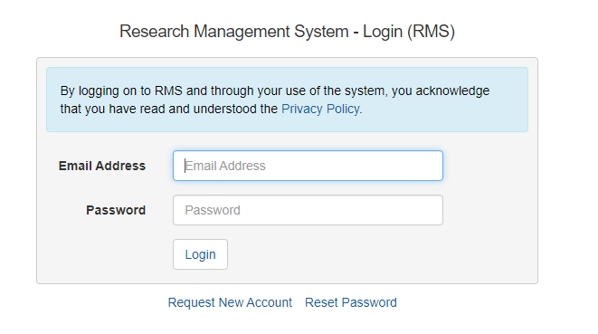

*Figure 1. Research Management System User Sign in page.*

The Multi Factor Authentication (MFA) is required to be set up to login and use your RMS account. Please follow the below instructions to set up your MFA access with your RMS account:

1. Download the MFA app on your smartphone (smartphone application examples are displayed in figure 2)
2. Using the chosen app on your smartphone, scan the QR code using the app
3. Use the most recent 6-digit code generated by the authenticator and enter it in the section – ‘Enter the 6-digit MFA code from your Authenticator App’
4. Password is your RMS password
5. Click on the ‘Setup MFA on your Account’ button.

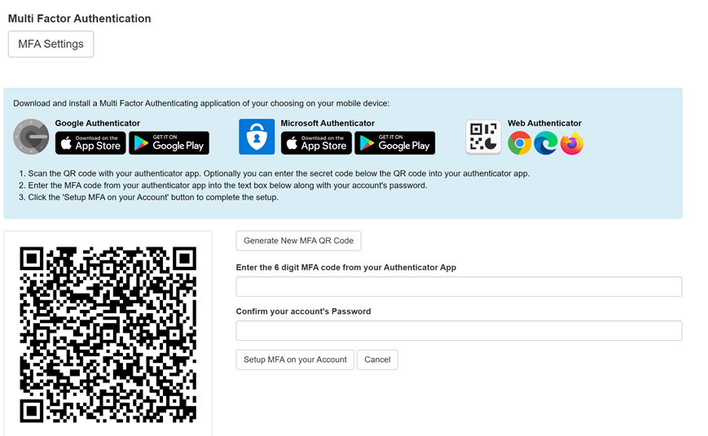

*Figure 2. Multi Factor Authenticating (MFA) setup page in RMS.*

1. Once you have done this, set up your ‘Person Profile’ in RMS as displayed below (**red circle**):

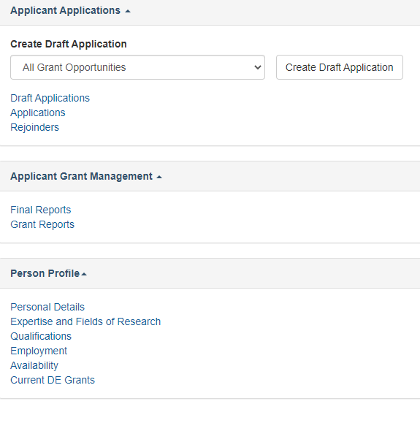

### 2.1 – RMS User profile and populating Research Outputs

Ensure the personal details, qualifications and employment history sections of the AEA applicant’s ‘Person Profile’ contains up-to-date information, as some of these details will be auto populated in the application form.

Research outputs can be added to a user’s profile through any of the following methods:

* Link an RMS account with an ORCID (Open Researcher and Contributor ID) account and import the research outputs from the Works section of the user’s ORCID profile.
* Add a research output citation by using a valid Digital Object Identifier (DOI).
* Upload a BibTeX file to RMS and perform a bulk upload of the research outputs contained within it; or
* Manually create an individual record per research output within the RMS user profile.

For instructions on how to address research outputs to your profile in RMS, refer to the User Guide: [RMS Auto-population of Research Outputs](https://www.arc.gov.au/manage-your-grant/research-management-system-rms-information/rms-auto-population-research-outputs) and [FAQS: RMS Auto-population of Research Outputs](https://www.arc.gov.au/manage-your-grant/research-management-system-rms-information/faqs-rms-auto-population-research-outputs) available on the ARC website.

**Note**: RMS will not prevent the entry of duplicate records and it is the responsibility of applicants to manage this. Users will have the flexibility to choose research outputs for listing in their grant applications.

## 

## 3. Creating an Ignite application in RMS

To create a draft grant application, see below instructions:

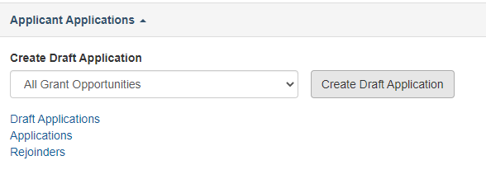

1. Login to [RMS](https://education.researchgrants.gov.au).
2. Select Australia’s Economic Accelerator Ignite Grant from the drop-down list and click on ‘Create Draft Application’.
3. There are five parts (A – E) in the AEA Ignite application form:
   * A) Administrative Summary
   * B) Business Case
   * C) Budget and Financial Information
   * D) Personnel
   * E) Partner Organisations
4. When the application has been created, the application form parts will be displayed at the top of the screen. The colour of these parts will be red indicating that the part is incomplete (invalid). When the application form parts have been completed, they will turn green (valid). Click on the relevant form part at the top of the screen to navigate between form parts (Part A to Part D)
5. Part E will appear once a partner organisation has been listed at question A3
6. Click on Part A to start filling in the application form
7. Move through the sections and enter the information of your grant

**RMS does not autosave your application. It is important to periodically save all changes. The ‘Save’ button is located at the top of the page next to the Adobe PDF file icon:**



**Note:** There is help text provided within the form to assist in completing questions. To access help information, click on the  icon.

### Part A – Administrative Summary

#### A1 – Project Title

Provide a short title (up to 200 characters, approximately 30 words). The application title:

* should be an accurate reflection of the project
* should **avoid**the use of acronyms and **should not**use all upper-case characters
* may be modified and used for public release.

#### A2 – Domestic Participating Organisations Summary

Add all organisations participating in this application. Select the relevant ‘Organisation Role’ from the drop-down list:

* enter the name of the organisation in the search box and click ‘Search’
* select the relevant organisation from the list of search results and click 'Add’.

The following organisations, as per the AEA Ignite Program Administrative Guidelines, can be added to the application:

|  |  |
| --- | --- |
| One Lead Organisation | It is a mandatory requirement to have a Lead Organisation and only one is allowed per application.  ‘Lead Organisation’ refers to the organisation that submits an application for funding, and which will be responsible for the administration of the funding if the application is approved. Under the *Higher Education Support Act 2003* (HESA) and the current legislative instrument, all Table A and Table B Australian Universities are eligible to be Lead Organisations for the AEA program. Lead Organisations can also be a bodies corporate listed in the ‘University College’ provider category listed in the *Higher Educations Standards Framework (Threshold Standards) 2021.*  The 6 University Colleges:   * Sydney College of Divinity Ltd. * Alphacrucis University College Ltd * Australian Film, Television and Radio School * Australian College of Theology Ltd * The National Institute of Dramatic Art * Moore Theological College Council |
| Collaborating Organisation/s | Collaborating Organisations must meet the eligibility criteria specified under section 2.2 of the AEA Ignite Program Administrative Guidelines. Collaborating organisations cannot be listed as the lead organisation on an application. Including a collaborating organisation is optional. |
| Partner Organisation/s | Partner organisations must meet the eligibility criteria specified under section 2.3 of the AEA Ignite Program Administrative Guidelines. Partner organisations must be Australian.  The applicant may nominate a partner organisation, but this is not a mandatory eligibility requirement. |

#### A3 - Person Participant Summary

Add all people participating in this application as a lead entrepreneur, collaborating entrepreneur, or partner entrepreneur(see AEA Ignite Program Administrative Guidelines document for definitions).

|  |
| --- |
| Important: Please note the completion of this question is dependent on the acceptance of invitations and the completion of question D2. Until all named applicants have accepted their invitations to the application and completed D2, Section A will not turn green. |

Select the relevant ‘Participation Type’ and enter the participant’s registered RMS email address, then click on ‘Add’. Repeat this action for the rest of the participants.

**Important:** ‘Person Profile’ details (personal details, qualifications, and employment) will be automatically populated into the application form and must be current at the time of submitting the application**. It is important that each participant has reviewed and updated their Personal Profile in RMS before completing this question**.

The following participants, as per the AEA Ignite Program Administrative Guidelines, can be added to the application:

|  |  |
| --- | --- |
| One Lead Entrepreneur (LE) | In accordance with Section 2.4 of the AEA Ignite Program Administrative Guidelines, to be eligible for the AEA Ignite Grant, applications must “nominate one Lead Entrepreneur (LE) that commits a minimum of 0.5 FTE to the project over its term”. It is a mandatory requirement to have a lead entrepreneur and only one is allowed per application. Refer to guidelines for additional eligibility requirements.  Collaborating and partner entrepreneurs cannot be the lead entrepreneur. |
| Collaborating Entrepreneur/s | Collaborating entrepreneurs must meet the eligibility criteria specified under Section 2.4 of the AEA Ignite Program Administrative Guidelines and must be affiliated with a lead or collaborating organisation.  It is optional to have a collaborating entrepreneur. However, if one is listed, their names and their organisation need to be provided in the application, along with details outlining their role. |
| Partner Entrepreneur/s | Partner entrepreneurs must meet the eligibility criteria specified under Section 2.4 of the AEA Ignite Program Administrative Guidelines.  It is optional to include a partner entrepreneur in an application. However, if a partner entrepreneur is listed, their names and their organisation need to be provided in the application, along with details outlining their role. |

**Note:**

* When a participant is added to the application, they will receive an automated email invitation and will be required to accept this invitation to participate in the application. When adding a participant, it is important to use the email address associated with their RMS account, so they receive an invitation to participate in the application.
* If the proposed participant does not have an RMS user account, they can request one by using the link found on the [RMS Homepage](https://education.researchgrants.gov.au/RMS/ActionCentre/Account/RegisterUser).
* For instructions on how to provide access to the application form for a non-participant, see the [RMS User Guide - Submitting an application in RMS.](https://www.arc.gov.au/grants/rms-information)
* If a participant fills out the application form and then changes their role (e.g., from lead entrepreneur to partner entrepreneur), this may result in some questions in the form being cleared and made inactive to suit the new role, and other questions which were formerly inactive now being made active and requiring a response.
* Applicants should carefully check the application following any role change made on an application form. It is strongly encouraged to have defined a participant’s role prior to commencing the application form.

#### A4 – Focus Areas

Select one of the options in the drop-down menu.

If your application does not relate to one of the focus areas, select ‘None of the above’

#### A5 – National Priority Areas

(as outlined in the [National Reconstruction Fund Corporation Priority Areas Declaration 2023](https://www.legislation.gov.au/F2023L00716/latest/text))

In AEA Ignite, consideration will only be given to projects addressing selected national priority areas. Please choose one priority area from the drop-down list. This information will be used for future reporting purposes if this application is funded. Please refer to the Department of Industry website for further information regarding the [National Reconstruction Fund Priorities (Industry.gov.au).](https://www.industry.gov.au/news/national-reconstruction-fund-diversifying-and-transforming-australias-industry-and-economy)

#### A6 – Project Aim

What is the overarching goal or purpose the project is attempting to achieve? Describe what the project intends to achieve upon completion in terms of outcome/s, value and include the current and anticipated Technology Readiness Level (TRL).

#### A7 – Project Objectives

Please list up to 4 specific and detailed goals that contribute to achieving the project aim. The project objectives should provide a roadmap for how the project will progress and what outcomes are expected. Please include up to 4 key objectives utilising the 'add answer' function below.

Each objective can be up to 750 characters, or approximately 170 words, per objective. This information will be used for future reporting purposes if this application is funded.

#### A8 – Public Project Summary

Provide a brief Public Project Summary for members of the general public. Focus on the aims, significance, expected outcomes and benefits of this project (up to 1,500 characters or approximately 250 words). Write simply, clearly and in plain English.

If the project is successful, the Project Summary will be used to give the general community an understanding of the project.

**Note:** The Public Project Summary may be modified by the department.

#### A9 – Technical Project Summary

Provide a technical project summary, focusing on the aims, significance, expected outcomes and benefits of this project (up to 1,500 characters or approximately 250 words). Write the technical project summary simply and clearly. Avoid the use of acronyms, quotation marks and unnecessary upper-case characters.

#### A10 - Proposed Length of Project

Projects must be between 3 months to 12 months in total duration. A drop-down box will provide options between 3 and 12 months to choose from. Please select the correct project length.

#### A11 – ANZSIC

Select one three-digit code from the [Australian and New Zealand Standard Industrial Classification](https://www.abs.gov.au/statistics/classifications/australian-and-new-zealand-standard-industrial-classification-anzsic/2006-revision-2-0/numbering-system-and-titles/division-subdivision-and-group-codes-and-titles) that most aligns with the application. ANZSIC is a standard classification for the analysis of industry statistics. We are interested to know which industry will benefit if your project is commercialised and reaches the market.

Once you choose the ANZSIC code click on the 'Add' button.

#### A12 – Field of Research (FOR-2020)

Select up to three six-digit [Field of Research (FOR) classification](https://www.abs.gov.au/statistics/classifications/australian-and-new-zealand-standard-research-classification-anzsrc/2020/anzsrc2020_for.xlsx) (FOR-2020) codes that relate to the application. The classification defines research according to disciplines. The FOR codes selected should reflect the nature of the research in this application, particularly if it is interdisciplinary.

When entering FOR codes:

* use descriptors or numeric codes to search for a FOR code
* select up to 3 classification codes that relate to the application. Enter in the percentage for each FOR classification. Once you choose the FOR code click on the 'Add' button.
* prioritise the classification codes from highest to lowest percentage
* ensure that the percentages total 100.
* enter a whole number, do not use the percentage sign (%).
* the highest percentage can only be entered for one FOR code (for example, 50 cannot be entered for two FOR codes).

**Note:** Select the six-digit FOR codes from the list of the FOR Codes carefully, as they contribute to the identification of the most appropriate assessors for the application. The Department of Education recommends that ‘XXX99’ (not elsewhere classified) codes be used only as a last resort when there is no other appropriate code within the classification.

#### A13 – Socio-Economic Objective (SEO-2020)

Select up to three SEO classification codes (SEO – 2020) that relate to the application. The [Socio‑Economic Objective (SEO) classification](https://www.abs.gov.au/statistics/classifications/australian-and-new-zealand-standard-research-classification-anzsrc/2020/anzsrc2020_seo.xlsx) indicates the sectors that are most likely to benefit from the project if funded.

When entering SEO codes:

* use descriptors or numeric codes to search for the SEO code
* select up to classification codes that relate to the application. Enter in the percentage for each SEO classification. Once you choose the SEO code click on the 'Add' button
* prioritise the classification codes from highest to lowest percentage
* ensure that the percentages total 100
* enter a whole number, do not use the percentage sign (%)
* the highest percentage can only be entered for one SEO code (for example, 50 cannot be entered for two SEO codes).

#### A14 – Current Technology Readiness Level

Please provide details of the technology/solution’s current state of development, overview of the research and development completed thus far, project momentum and explanation for confidence in the potential of the solution. Select the [Technology Readiness Level (TRL)](https://www.dst.defence.gov.au/sites/default/files/basic_pages/documents/TRL%20Explanations_1.pdf) the project is currently at. For AEA Ignite, the starting TRL stages are between 3 and 5.

Use the drop-down box to select the TRL the project is currently at. Use the explanation text to articulate the current TRL.

#### A15 – Anticipated Technology Readiness Level

Please provide details of the technology/solution’s anticipated state of development, overview of the R&D to be completed, project momentum and explanation for confidence in the potential of the solution. Select the [Technology Readiness Level (TRL)](https://www.dst.defence.gov.au/sites/default/files/basic_pages/documents/TRL%20Explanations_1.pdf) you anticipate the grant will progress the project to.

There is no requirement for AEA Ignite applications to increase the anticipated Technology Readiness Level of a project by completion. However, if it does not expect to increase the anticipated Technology Readiness Level, the project must demonstrate progress within the Technology Readiness Level.

|  |
| --- |
| Note: For the avoidance of doubt, AEA Ignite projects can progress to a TRL beyond 5, up to 7, at the end of the grant. |

Use the drop-down box to select the Technology Readiness Level the grant will progress the project to. Use the explanation text to articulate the anticipated Technology Readiness Level or the expected progress within the Technology Readiness Level.

#### A16 – Will this project fund research students?

For reporting purposes, the AEA is capturing the number of Research Students that will contribute to this project if successful. This includes Research Students not funded directly from an AEA Ignite grant.

Select the number of students for *each student category* (full-time equivalent) that will be filled as a result of this project, not just those requested in the budget for funding in the application form e.g., Honours: 1, Masters: 0, or PhD: 2. Answers can be provided down to one decimal place.

#### A17 – Where is your research being undertaken?

Indicate the state/territory and postcode for the primary facilities where this research will be conducted. If there are multiple locations, please list them as secondary locations alongside their postcodes. this list should include locations of collaborating and partner organisations, wherein research is being conducted. Use the text box to indicate the primary research activities being undertaken at these facilities.

#### A18 – Does the proposed research involve international collaboration?

This is a 'Yes' or 'No' question. If you select ‘Yes’, 2 additional questions will be enabled:

* specify the nature of the international collaboration by selecting one or more of the options below.
* use the text box to indicate the nature of the international collaboration involved (up to 1200 characters, approximately 200 words).

#### A19 – If the proposed research involves international collaboration, please specify the country/ies involved.

Indicate the countries involved in the international collaboration. Start typing in the search box and select from the drop-down list the name of the country/ies of collaborators who will be involved in the proposed project.

Note that Australia is not to be listed and is not available to be selected from the drop-down list.

### Part B – Business Case

#### B1 – Business Case

Upload a business case as a PDF file of no more than five pages, using the AEA Ignite Business Case Template located on the AEA website. Ensure that your text is readable both online and in print. For this reason, 11-12 pt font is recommended. Applicants should ensure that information provided addresses the selection criteria as detailed in section 4.1 of the AEA Ignite Program Administrative Guidelines.

#### B2 ­– Milestones – Timeline and Outcomes

A milestone is a point in the project where a group of tasks or activities have been undertaken to reach this point. Tangible products generated as part of the project are deliverables. Include in this section a list of the deliverables and their contents (if appropriate) to be produced during the project. Use this table to list specific deliverables agreed upon by the lead entrepreneur.

For each milestone listed there should be a corresponding:

* milestone description
* deliverable description
* program measure of success description
* how many months will it take you to reach this milestone.

For the purposes of the AEA Ignite, measures of success must include a selection of the following:

* improving the TRL of the project
* increased industry engagement through collaboration, investment, product development
* securing IP, Licensing or Patent agreements for the research.
* improved capability and understanding of the commercial opportunities relevant to your field of research.
* enhanced researcher/academic preparedness to explore research projects with identifiable commercial outcomes.
* a spinout/startup or SME (small medium sized enterprises).

#### B3 – Business Risk Management

The Risk Management Plan captures business and technical risks identified in the context of the ability to deliver the project, descriptions, and the associated mitigation strategies.

Business risks relate to the market and strategic aspects of commercialisation. They involve uncertainties in market demand, competition, access to people/resources, intellectual property, regulation, pricing, marketing, and sales.

The general description should describe the risk, its likelihood and impact/consequence.

The mitigation strategy for each risk should include an assessment pre-mitigation, an explanation of the mitigation strategy/ies and the assessment of residual risk.

A minimum of one and maximum of 3 business risks must be provided.

#### B4 – Technical Risk Management

The Risk Management Plan captures business and technical risks identified in the context of the ability to deliver the project. It should include descriptions of the risks and the associated mitigation strategies.

Technical risks relate to the technology or product development and implementation. They involve uncertainties or challenges in research/product development, scalability, or unexpected technical limitations.

The general description should describe the risk, its likelihood and impact/consequence.

The mitigation strategy for each risk should include an assessment pre-mitigation, an explanation of the mitigation strategy/strategies and the assessment of residual risk.

A minimum of one and maximum of 3 technical risks must be provided.

#### B5 – Staffing Risk Management

Staffing risks relate to personnel and staffing challenges that may affect the progression of the project. They involve uncertainties or challenges in the onboarding, retention and capacity of the project team.

The general description should describe the risk, likelihood and impact/consequence.

The mitigation strategy for each risk should include an assessment pre-mitigation, an explanation of the mitigation strategy/ies and the assessment of residual risk.

A minimum of 1 and maximum of 3 risks must be provided for staffing risks.

### Part C – Budget and Financial Information

#### C1 – Are you requesting $200,000 or more in grant funding for this application?

Answer whether you are requesting $200 000 or more in AEA funding for this application. If yes is selected, the following instruction text will be displayed:

|  |
| --- |
| As you are requesting $200,000 or more in grant funding, you must provide a detailed budget breakdown in at least two phases in question C2 - Project Budget. For further information and an example of how to provide correct phased budget information, please see Part C in the Ignite Applicant’s Guide. Failure to provide correctly phased budget information may result in ineligibility. |

The eligibility criteria related to this question states: “*applications seeking $200,000 or more in grant funding must identify and cost at least two phases of work and provide a description in the Budget Explanation of the application form in RMS”.*

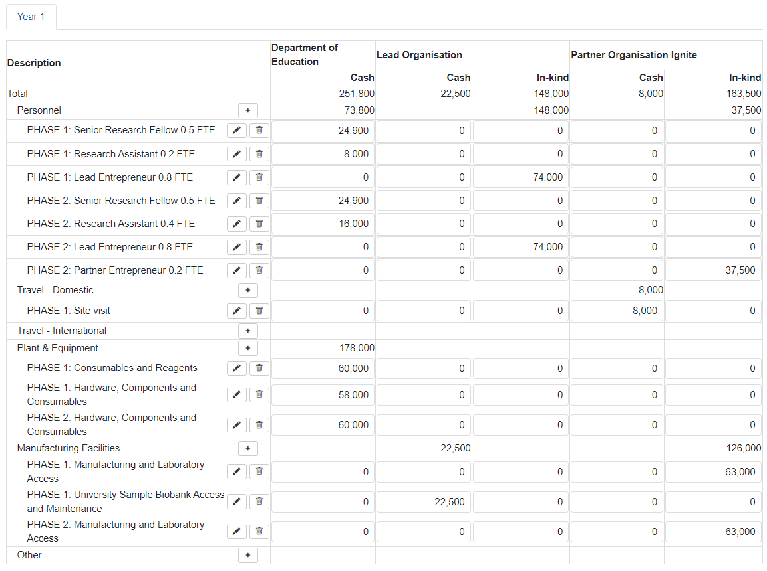The image above shows a correctly phased budget table completed in RMS, for an application requesting $200,000 or more in grant funding. The above example demonstrates how the project has been broken down into at least **2 distinct** phases, and every budget line item included in the budget table is attributed to one of these phases.

Example of a correctly phased budget - question C2 of the application form:

#### C2 - What is the proposed budget for your project?

The AEA reserves the right to determine the level of funding allocated to a project.

Outline the budget proposed for the project.

Please ensure that your budget complies with the requirements of the AEA Ignite Program Guidelines. It is important that all participating organisations and entrepreneurs have been added to the RMS application prior to commencing information in the budget table.

Funding must not be requested for items that are excluded. Refer to the AEA Ignite Program Administrative Guidelines for further information on budget items supported and not supported.

Ensure that the funding is requested at the correct level as the AEA will not provide additional funds to cover a budget that has not been planned adequately. For AEA Ignite Grants, minimum grant application is $50,000 and maximum grant application is up to a total of $500,000.

Do not include GST in your costs.

Cash and in-kind (goods, services, and transactions not involving money) for each organisation should be shown.

Categorise items using the following headings:

* Personnel
* Expert Services
* Travel – Domestic
* Travel – International
* Plant & Equipment
* Other.

#### C3 – Budget Explanation – AEA Ignite

Detail the ways in which you propose to spend AEA Ignite funds and explain any institutional overheads and on-costs. Outline separate answers for each organisation.

**If you are requesting more than $200,000, ensure you have identified at least 2 phases of work in your budget, that break the project into distinct steps. In this section include an aggregate cost for each individual phase.**

Please note:

* Use the budget categories specified in C2 as headings
* Justify each budget item requested in terms of need and cost
* Justify any funding being requested for major items of equipment. Requests for major items of equipment are considered on merit. The participant should plan to use existing equipment wherever possible. If the participant is seeking funding for new equipment, describe how the equipment will be used and supplied.
* Requests for funding to cover the costs of domestic and international travel, including for reasons of fostering and strengthening collaborations in Australia and overseas, must be justified in full.

#### C4 – Budget Explanation – Lead Organisation

Detail the ways in which funds (both cash and in-kind) from the lead organisation are proposed to be spent and explain any institutional overheads and on-costs. Please note:

* Add separate answers for each organisation as required.
* Use the budget categories specified in C2 as headings.
* Provide details including what each participant (if relevant) will contribute to the project in relation to their time and any other contribution of their organisation.
* If there is no direct funding being provided by a participating organisation in cases where this could reasonably be expected, explain fully why no commitment has been made.

#### C5 – Budget Explanation – Collaborating Organisation/s

Detail the ways in which funds (both cash and in-kind) from collaborating organisation/s are proposed to be spent and explain any institutional overheads and on-costs. Please note:

* Add separate answers for each organisation, as required.
* Use the budget categories specified in C2 as headings.
* provide details including what each participant (if relevant) will contribute to the project in relation to their time and any other contribution of their organisation.
* If there is no direct funding being provided by a participating organisation in cases where this could reasonably be expected, explain fully why no commitment has been made.

#### C6 – Budget Explanation – Partner Organisation/s

Detail the ways in which funds (both cash and in-kind) from Partner Organisation/s are proposed to be spent and explain any institutional overheads and on-costs. Please note:

* Add separate answers for each organisation, as required.
* Use the budget categories specified in c2 as headings.
* Provide details including what each participant (if relevant) will contribute to the project in relation to their time and any other contribution of their organisation.
* If there is no direct funding being provided by a participating organisation in cases where this could reasonably be expected, explain fully why no commitment has been made.

#### C7 – Previous funding for this project (non AEA grant funding)

Have you received prior funding for this research? If ‘yes’, please provide:

* funding project ID
* name of funder
* project title
* total amount
* detail regarding how this grant will differ from previous funding for this research.

#### C8 – Have you previously applied for any AEA grants?

Please answer yes or no if you have applied or received funding for previous AEA Seed, Ignite and/or Innovate grant rounds for projects with the same or similar research. If yes, please provide:

* previous application number(s)
* did you receive funding?
* please indicate which of the previous applications were funded.

### Part D – Personnel

**Important**: For all questions relating to **Part D**, please ensure that the information you provide is true and correct. Please note that any wilful dishonesty may **render the application being removed** from the process.

#### D1 – Entrepreneur

**This data is automatically populated from the participant’s RMS profile.**

Questions in a participant’s person profile can only be answered by the respective participant. The lead organisation will not be able to edit this information on behalf of participants.

To update the ‘Personal Details’ section, click on the ‘Manage Personal Details’ link. Note this will open a new browser tab. When returning to the form ensure to ‘Refresh’ the page to capture the changes made to the participant's profile.

The following data is automatically populated from the candidate’s RMS profile into the application:

* participation type
* title, first name, middle name, family name, phone number, email address, date of birth, country of birth, gender, citizenship, Australian residency, languages other than English, Indigenous status
* material personal interest questions as follows:
* Are you currently receiving any financial support (cash or in-kind) for research related activities from a country other than Australia?
* Are you currently, or have you previously been, associated or affiliated with a talent recruitment program from a country other than Australia?
* Are you currently associated or affiliated with a government, intelligence organisation, government owned enterprise, military, or police organisation in a country other than Australia?
* Have you identified and disclosed any conflicts of interests in accordance with your Institution’s conflict of interest policies and procedures? This question serves as a declaration that:

1. You have one or more Conflicts of Interest (COIs) and have disclosed them to your employing institution, and if relevant, Lead Organisation(s) of Department of Education grant applications as required by the institution(s)'s COI policies and procedures or
2. You do not have any COIs and have followed the relevant institution(s)'s COI policies and procedures (which may include reporting you have nil COIs).

In both cases you should answer 'Yes' to this question.

A 'No' answer to this question indicates that you have a COI that you have not disclosed to your employing institution or relevant Lead Organisation(s) of Department of Education grant applications. In this case you will be prevented from participating on a Department of Education grant application.

* Has the participant acknowledged the collection of personal information by the Department of Education?

For the application form to become valid the participant must acknowledge the collection of personal information within the profile.

**Note:** The phone number, date of birth, country of birth, citizenship, material personal interests, and indigenous status responses will not be visible to the Priority Managers assessing applications. However, all information contained in Part D is visible to the Lead Organisation and project participants on this application, as well as the Department.

|  |
| --- |
| Important: If an applicant fails to appropriately fill out this information this will not be populated into the application form and may result in ineligibility. |

#### D2 – Eligibility – Organisation applicant is engaged with at the commencement of this project

Enter the organisation that you are/will be engaged with at the commencement of your participation in this project. Note that the organisation must be listed in question A3 for this question to validate.

The ‘relevant organisation’ is the primary organisation that will be supporting your involvement in this project if it is funded.

#### D3 – Qualifications

This data is automatically populated from the participant’s RMS profile.

Questions in a participant’s person profile can only be answered by the respective participant. The lead organisation is not able to edit this information on behalf of participants.

To update any qualifications, click on the ‘Manage Qualifications’ link. Note this will open a new browser tab. When returning to the form ensure to ‘Refresh’ the page to capture the changes made to the participant's profile.

#### D4 – What will your time commitment be to research activities related to this project?

Each participant’s time commitment to this project should be entered as a full-time equivalent (FTE).

For LE there is a minimum FTE commitment expected for the project of .5 FTE.

#### D5 – What is your role and responsibility in this project?

Please provide a short description of your role and responsibility as an entrepreneur in this project.

#### D6 – Commercialisation and Industry Collaboration Experience

Provide a short description of your commercialisation and industry collaboration experience, including relevant professional development undertaken in the past ten years. For example, have you participated in any commercialisation programs (such as [CSIRO's ON program](https://www.csiro.au/en/work-with-us/funding-programs/innovation-programs))?

#### D7 – ORCID link

ORCID (Open Researcher and Contributor ID) is an open, non-profit, community-driven effort to create and maintain a registry of unique researcher identifiers and a transparent method of linking research activities and outputs to these identifiers.

Please provide a link to the participant’s ORCID profile, e.g., <https://orcid.org/0000-0000-0000-0000>.

#### D8 – Professional Profile

Please upload a 1–3-page professional profile. This profile should outline relevant employment history, documentary evidence of your top 3 research publication, relevant to the project you are applying for industry experience. This information should directly reflect the research and experience pertinent to this project.

#### D9 – Conflict of Interest (COI)

Do you have any actual, perceived or potential conflicts of interest in relation to any aspect of the application/ project in accordance with your Institution’s conflict of interest policies and procedures?

In accordance with the AEA Ignite Program Administrative Guidelines, each individual or organisation named in an application must declare any actual, perceived, or potential conflict of interest that exists within and outside Australia, is likely to arise, or does arise in relation to any aspect of the application or project to the applicant for inclusion in the application.

#### D10 – Certification by Participants

The participant is required to provide certification of all relevant clauses. The certification includes the review and confirmation of the accuracy of all information contained in the application, including information entered within the participant’s Person Profile.

The application form will not validate if ‘No’ is selected.

### Part E – Partner Organisation

Partner organisations are auto populated from question A3.

#### E1 – Partner Organisation ABN

Provide each Partner Organisation’s Australian Business Number (ABN). If you do not know your Partner Organisation’s ABN please use the [ABN Lookup](https://abr.business.gov.au/) to find the relevant ABN. In AEA Ignite all listed Partner Organisation must provide a valid ABN.

#### E2 – Partner Organisation Declaration (POD)

Upload a single Partner Organisation Declaration Form for each listed Partner Organisation.

Each letter (1 page minimum, 2 pages maximum) should be prepared in accordance with the Partner Organisation Declaration template available in Appendix B of the AEA Ignite Program Administrative Guidelines. The declaration form reads:

To whom it may concern

I am writing on behalf of *[Partner Organisation]* to provide our support for the funding application: *[AEA Ignite Application Number] [AEA Ignite Application title].*

*[Please use up to two pages to provide the details of:*

* *the Partner Organisation*
* *an overview of how the Partner Organisation will work with the other participating organisation/s to successfully complete the project*
* *an outline of the relevant experience and/or expertise the Partner Organisation will bring to the project]*

 Total partner contributions over the Project funding term are listed below and are consistent with the total contributions listed in the application:

|  |  |
| --- | --- |
| **Contribution Type** | **Amount** |
| **Cash ($AUD) for grant period** | $ |
| **FTE (to two decimal points) for funding term (in-kind)** |  |
| **FTE ($AUD) for funding term (in-kind)** | $ |
| **Non-staff in-kind ($AUD) for funding term** | $ |

**Declaration**

On behalf of *[insert Partner Organisation]* I declare that, should this application be successful, the Partner Organisation:

* *Is aware of the requirements related to Partner Organisations under the AEA Ignite Program Administrative Guidelines.*
* *Will support and actively participate in the proposed AEA Ignite project.*
* *Will contribute the staff, funds and other resources indicated in the application and has obtained, or will obtain, the necessary authorisations to do so.*
* *Confirms that cash contributions are not sourced from Commonwealth Government funds for the purposes of research, including the Research and Development Tax Incentive (R&D Tax Incentive or R&DTI).*
* *Will comply with and require that its subcontractors and independent contractors comply with, all applicable laws.*
* *Information contained in this application, together with any statement provided, is to the best of my knowledge, true, accurate and complete. I also understand that the giving of false or misleading information is a serious offence.*
* *Acknowledges that if the department is satisfied that any statement made in an application is incorrect, incomplete, false or misleading, the department may, at its absolute discretion, take appropriate action.*
* *Understands that they may be requested to provide further clarification or documentation to verify the information supplied in this form and that the department may, during the application process, consult with other government agencies, including State and Territory government agencies, about the Lead Organisation’s claims and may also engage external technical or financial advisers to advise on information provided in this form and the application.*
* *Provides consent to be contacted by the department to discuss the particulars of the partner’s commitment to the proposed Ignite project*
* *Approves of the information in this form being communicated to the department in electronic form.*

**Signing**

By signing below, I agree that I am authorised to sign and submit this declaration on behalf of the Partner Organisation and confirm all of the above statements to be true.

|  |  |
| --- | --- |
| **Partner (organisation name):** |  |
| **Partner ABN/ACN:** |  |
| **Authorised representative (name):** |  |
| **Position/role:** |  |
| **Phone:** |  |
| **Email:** |  |
| **Signature:** |  |
| **Date:** |  |

#### E3 – Partner Organisation’s ASIC documentation

Upload a single document per listed Partner Organisation. Each upload (minimum 2 page, maximum 40 page) should describe the nature of the organisation’s structure and ownership and include:

* current and historical company information
* roles and relationship extract
* capitalisation (CAP) table for each partner organisation

If a Partner Organisation or company is not registered with ASIC, then equivalent documentation needs to be provided which demonstrates that the organisation is not part of the excluded category described in the Guidelines.

## Contact and Further Information

For enquiries about AEA Ignite, applicants should seek advice from their institutional research office (or equivalent). Research office staff can email [accelerator@education.gov.au](mailto:) for further advice if queries cannot be answered by the Program Guidelines, Applicants Guide, or Frequently Asked Questions.