****Australian Government
Australia's Economic Accelerator

# Australia’s Economic Accelerator

Applicant’s Guide for the AEA Innovate Grants

Version 2.1 last updated August 2025



With the exception of the Commonwealth Coat of Arms, the Department’s logo, any material protected by a trademark and where otherwise noted all material presented in this document is provided under a [Creative Commons Attribution 4.0 International](https://creativecommons.org/licenses/by/4.0/) (https://creativecommons.org/licenses/by/4.0/) licence.

The details of the relevant licence conditions are available on the Creative Commons website (accessible using the links provided) as is the full legal code for the [CC BY 4.0 International](https://creativecommons.org/licenses/by/4.0/legalcode) (https://creativecommons.org/licenses/by/4.0/legalcode)

The document must be attributed as the Applicant’s Guide for the Australia’s Economic Accelerator (AEA) Innovate Grants Program.

Contents

Australia’s Economic Accelerator 1

1. Introduction 4

2. Instructions on creating an RMS User profile 7

3. AEA Innovate Expression of Interest (EOI) 10

EOI Privacy Statement 10

Innovate Grant Eligibility Checklist 10

EOI Part A – Administrative Summary 10

EOI Part B – Eligibility 12

EOI Part C – Project Summary 12

EOI Part D – Personnel 13

4. Creating an Innovate application in RMS 14

Creating a full application from an EOI 14

Application overview 15

Part A – Administrative Summary 16

Part B – Selection Criteria 23

Part C – Budget and Financial Information 24

Part D – Personnel 25

Part E – Collaborating and Partner Organisation 30

Contact and Further Information 33

## 1. Introduction

The Applicant’s Guide for Australia’s Economic Accelerator (AEA) Innovate Grants(hereafter referred to as the Guide) provides information to participants on how to complete and electronically submit an AEA Innovate proposal for funding.

The completed online [Research Management System](https://aea_education.researchgrants.gov.au/) (RMS) application form, including PDF attachments, must comply with the AEA Innovate Program Administrative Guidelines. You should read the AEA Innovate Program Administrative Guidelines before preparing the online RMS application. While all care has been taken to ensure correctness, in the event of any inconsistency between this Guide and the AEA Innovate Program Administrative Guidelines, the Guidelines should be considered authoritative.

For general instructions on how to use the Research Management System (RMS), refer to instructions below or access User Guides ([RMS User Guide](https://www.arc.gov.au/sites/default/files/2022-06/rms_user_guide_3.0_0_.pdf) and [Submitting an Application in RMS](https://www.arc.gov.au/sites/default/files/2022-08/Submitting%20an%20Application%20in%20RMS%202.1.pdf)) available on the ARC Website.

In addition to the instructions, applicants should familiarise themselves with associated documentation such as:

| Document name | Location |
| --- | --- |
| AEA Innovate Program Administrative Guidelines | [AEA Website](https://www.aea.gov.au/researcher-applicant/funding/aea-ignite) |
| Government identified national priority areas of the economy | [Priority areas – Industry.gov.au](https://www.nrf.gov.au/what-we-do/our-priority-areas) |
| Key dates | [AEA Innovate - Australia's Economic Accelerator, Australian Government](https://www.aea.gov.au/researcher-applicant/funding/aea-innovate) |
| RMS User Management Guide and Submitting an Application in RMS Guide | [RMS User Guide](https://www.arc.gov.au/sites/default/files/2022-06/rms_user_guide_3.0_0_.pdf)  [Submitting an Application in RMS](https://www.arc.gov.au/sites/default/files/2022-08/Submitting%20an%20Application%20in%20RMS%202.1.pdf) |
| Technology Readiness Level definitions | [Technology Readiness Level definitions](https://www.dst.defence.gov.au/sites/default/files/basic_pages/documents/TRL%20Explanations_1.pdf) |

Table 1: Important documentation and their locations

* 1. **Research Office – Further RMS application assistance/guidance**

The research office or technology transfer office (or equivalent) of the lead organisation should be contacted in the first instance to assist with queries on how to complete an online RMS application.

* 1. **Accuracy of information**

Carefully check that all information contained in the online RMS application is accurate prior to submission, as you cannot make changes once the online RMS application is submitted.

* 1. **Eligibility in RMS**

The lead organisation is responsible for confirming all eligibility requirements for the organisations and personnel have been met.

* 1. **Application Certification**

The online application form must be certified and submitted through RMS by an authorised officer of the lead organisation. The authorised officer must have the role of ‘Lead Organisation Delegate’ in RMS. Only the lead organisation can certify and submit the RMS applications online.

Certification for:

* named individual participants
* lead organisation, and
* partner organisation/s certification must be provided by uploading a signed Partner Organisation Declaration Form (template available from Appendix C in the AEA Innovate Program Administrative Guidelines). 
  1. **PDF Application**

All questions, except where identified, will render to a PDF generated from the RMS application form. Ensure that all text, including uploaded documents, is readable both online and in print (it is recommended that 11-12 pt font is used). This includes ensuring readability of text within figures and tables (it is recommended that 10pt font is used).

Information provided in the online RMS application should:

* only use webpage addresses/URLs and hyperlinks in limited circumstances such as where research outputs are only available online. Webpage addresses/URLs and hyperlinks should not be used to circumvent page limits, nor should they provide information that is not contained in the online RMS application.
* only include information which is pertinent to the research and note that colour graphs, colour photographs, detailed graphics and grey scale objects may be reproduced in black and white and should both be necessary and appropriate.

Additional text uploaded as a PDF may appear slightly reduced in size due to the RMS formatting of the attachments to include page numbers. Additional text uploaded in the PDF form should be directly generated rather than scanned to maximise the quality of reproduction.

Applicants should avoid using advanced PDF editing functionality such as the addition of textboxes, as this may not be supported in RMS. Applicants should carefully check that any changes made to a PDF document appear correctly in the application PDF in RMS.

The Department of Education (the department) reserves the right to seek an original electronic copy of documents uploaded into the online RMS application to determine that the text meets these requirements.

## 2. Instructions on creating an RMS User profile

To gain access to RMS, use the [RMS link](https://aea_education.researchgrants.gov.au/) and access the log in page.

1. Request a new account (**green**).
2. You will receive an email in the next day or so advising you now have RMS production. access.
3. Use the link again and go in and add a password to your account.

An example is displayed below of the RMS User sign in.

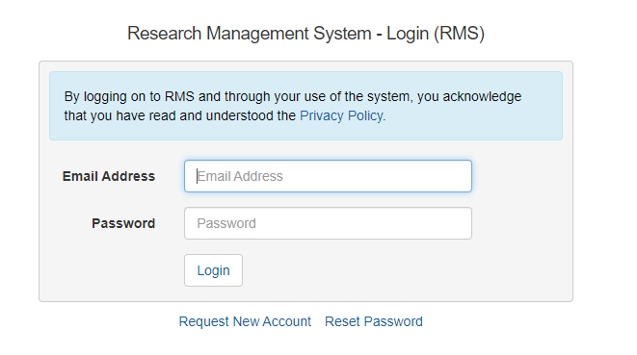

*Figure 1. Research Management System user sign in page.*

The Multi Factor Authentication (MFA) is required to be set up to login and use your RMS account. Please follow the instructions below to set up your MFA access with your RMS account:

1. Download the MFA app on your smartphone (smartphone application examples are displayed in figure 2)
2. Using the chosen app on your smartphone, scan the QR code using the app
3. Use the most recent 6-digit code generated by the authenticator and enter it in the section – ‘Enter the 6-digit MFA code from your Authenticator App’
4. Password is your RMS password
5. Click on the ‘Setup MFA on your Account’ button.

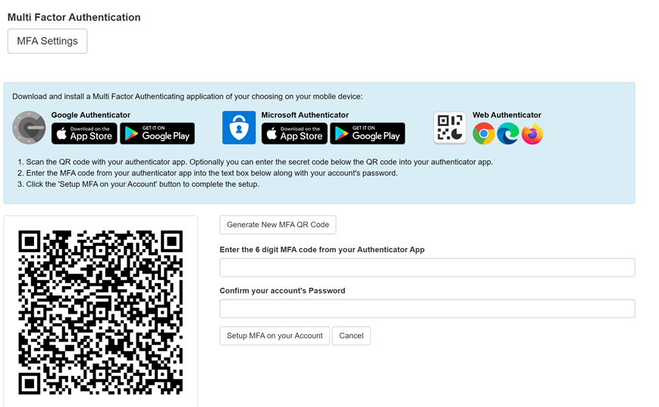

*Figure 2. Multi Factor Authenticating (MFA) setup page in RMS.*

1. Once you have done this, set up your ‘Person Profile’ in RMS as highlighted below (**red square)**:

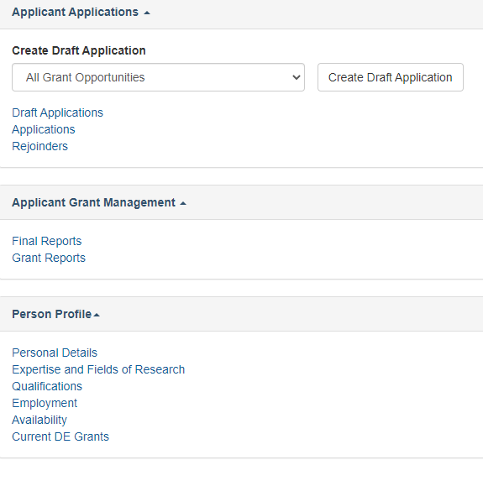

**2.1 RMS User profile and populating Research Outputs**

Ensure the personal details, qualifications and employment history sections of the AEA applicant’s ‘Person Profile’ contains up-to-date information, as some of these details will be auto populated into the online RMS application form.

Research outputs can be added to a user’s profile through any of the following methods:

* Link an RMS account with an ORCID (Open Researcher and Contributor ID) account and import the research outputs from the Works section of the user’s ORCID profile.
* Add a research output citation by using a valid Digital Object Identifier (DOI).
* Upload a BibTeX file to RMS and perform a bulk upload of the research outputs contained within it; or
* Manually create an individual record per research output within the RMS user profile.

For instructions on how to address research outputs to your profile in RMS, refer to the User Guide: [RMS Auto-population of Research Outputs](https://www.arc.gov.au/manage-your-grant/research-management-system-rms-information/rms-auto-population-research-outputs) and [FAQS: RMS Auto-population of Research Outputs](https://www.arc.gov.au/manage-your-grant/research-management-system-rms-information/faqs-rms-auto-population-research-outputs) available on the ARC website.

**Note**: RMS will not prevent the entry of duplicate records and it is the responsibility of applicants to manage this. Users will have the flexibility to choose research outputs for listing in their grant proposals.

## 3. AEA Innovate Expression of Interest (EOI)

To be eligible to submit a full application for AEA Innovate, Lead Organisations must submit an EOI application through RMS web portal.

### EOI Privacy Statement

Confirm that you agree to the collection, use and disclosure of your personal information, in the ways described.

The department is bound by the Privacy Act 1988 (Cth) (Privacy Act), including the Australian Privacy Principles (APPs) contained in Schedule 1 of the Act. The APPs govern the way the department and its contracted service providers handle personal information. This includes how we collect, use, disclose and secure personal information.

### **Innovate Grant Eligibility Checklist**

Before commencing your EOI application, please ensure that your application matches the eligibility criteria set out in section 2 of the AEA Innovate Program Administrative Guidelines.

### EOI Part A – Administrative Summary

#### **EOI Question A1 – Project Title**

Provide a short title (up to 200 characters or approximately 25 words). The proposal title:

* should be an accurate reflection of the project
* avoidthe use of acronyms and **do not** use all upper-case characters
* may be modified and used for public release.

#### **EOI Question A2 – Domestic Participating Organisations Summary**

Add all organisations participating in this proposal. Select the relevant ‘Organisation Role’ from the drop-down list:

* enter the name of the organisation in the search box and click ‘Search’
* select the relevant organisation from the list of search results and click 'Add’.

The following organisations, as per the AEA Innovate Program Administrative Guidelines, can be added to the proposal:

|  |  |
| --- | --- |
| One lead organisation | Lead organisations must meet the eligibility criteria specified under section 2 of the AEA Innovate Program Administrative Guidelines. It is a mandatory requirement to have a lead organisation and only one is allowed per proposal. |
| Collaborating Organisation/s | Collaborating organisations must meet the eligibility criteria specified under section 2 of the AEA Innovate Program Administrative Guidelines.  Collaborating organisations cannot be listed as the lead organisation on a proposal. Including a collaborating organisation is optional. |
| Partner Organisation/s | Partner organisations must meet the eligibility criteria specified under section 2 of the AEA Innovate Program Administrative Guidelines.  The applicant may nominate a partner organisation, but this is not mandatory at the EOI stage. An eligible partner organisation must be identified at the full application stage. |

EOI Question A3 – Person Participant Summary

Add all people participating in this application as a lead entrepreneur, collaborating entrepreneur or partner entrepreneur (see AEA Innovate Program Administrative Guidelines for definitions.)

* Select the relevant ‘Participation Type’ and enter the participant’s registered RMS email address, then click on ‘Add’.
* Repeat this action for the rest of the participants.

**Note:**

* One lead entrepreneur is required.
* There is no requirement to include, or limitation on the number of, collaborating entrepreneurs or partner entrepreneurs.

#### **EOI Question A4 – University Contact**

Provide the university contact name and phone number.

#### **EOI Question A5 – Priority Manager**

Indicate if you have been in contact with an AEA Priority Manager in relation to this project.

Please contact your research office or technology transfer office in the first instance to contact a priority manager.

#### EOI Question A6 – Previous AEA Application

Please provide the- project(s) number(s) and title(s) of any applications you have made under Seed, Ignite or Innovate (including EOI).

### EOI Part B – Eligibility

#### EOI Question B1 – Is your project TRL Level between 5-7?

Yes/No.

It is an eligibility requirement for projects to be between TRL 5-7 to apply for AEA Innovate grants. Please select an option between 5-7 to proceed.

#### EOI Question B2 – Is your project aligned with at least one of the following national priority areas?

Yes/No.

It is an eligibility requirement for projects to be aligned with one of the 7 priority areas.

#### EOI Question B3 – Will you have at least one Australian partner organisation who will provide resources to your project (cash or in-kind) in your full application?

Yes/No.

#### EOI Question B4 – Will you have matched funding from your participating organisations for the project?

Yes/No.

#### EOI Question B5 – Have you received funding from another Commonwealth or Australian state or territory government source for the same stages of development as in your Innovate grant proposal?

Yes/No.

Please provide details of the funding source.

#### EOI Question B6 – Proposed length of Project

Please select an option between 3-24 Months.

### EOI Part C – Project Summary

Please complete questions C1—C9, noting the help instructions in the RMS application from.

### EOI Part D – Personnel

#### EOI Question D1 – Entrepreneur

This data is automatically populated from the participant’s RMS profile. Please update your RMS profile in the relevant sections to update the details collected in this section.

Please identify if you have not disclosed any conflicts of interests in accordance with your Institution’s conflict of interest policies and procedures.

Please also acknowledge the collection of personal information by the department.

#### EOI Question D2 – Conflict of Interest (COI)

Do you have any actual, perceived or potential conflicts of interest in relation to any aspect of the application/ project in accordance with your Institution’s conflict of interest policies and procedures?

In accordance with the AEA Innovate Program Administrative Guidelines, each individual or organisation named in an application must declare any actual, perceived, or potential conflict of interest that exists within and outside Australia, is likely to arise, or does arise in relation to any aspect of the application or project to the applicant for inclusion in the application.

Please describe: the nature of this Conflict of Interest; how this conflict might influence or be seen to influence you; and the activities to be undertaken to mitigate, avoid, or resolve the conflict.

#### EOI Question D3 – Eligibility – Relevant Organisation

Enter the organisation that is relevant to your participation on this application, and that you will be associated with as at project commencement date. The ‘relevant organisation’ is the primary organisation that will be supporting your involvement in this project if it is funded. Note that the organisation must be listed in A2 for this question to validate.

#### EOI Question D4 Certification by participants

The participant is required to provide certification of all relevant clauses. The certification includes the review and confirmation of the accuracy of all information contained in this application, including information entered within the participant’s personal profile.

The online RMS application form will not validate if ‘No’ is selected.

## 4. Creating an Innovate application in RMS

### Creating a full application from an EOI

Outside of RMS, applicants will be notified of outcomes and will be able to create and submit a full application. **The lead organisation is the only user role able to commence a full application**, therefore they must create the full application for the lead entrepreneur to complete.

* 1. From the *Lead Organisation Expression of Interest Management* module of the Action Centre, select *Lead Organisation Expression of Interest Outcomes.*
  2. Under *Grant Opportunity* select the relevant round.
  3. To create an application, select the *Create/Update Application button*.

Screenshot of create/upload application interface

* 1. This action will create the application. Select *Save*

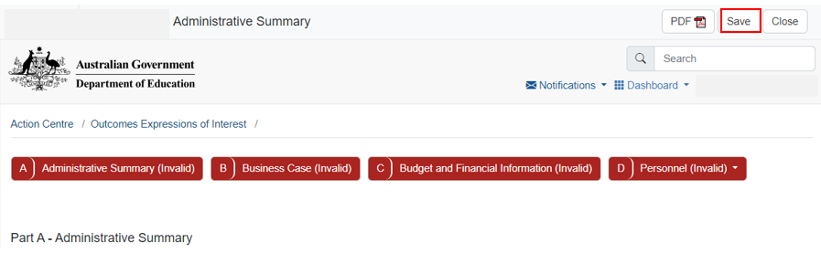

* 1. Once the application has been created and saved the lead entrepreneur will see the draft application in their RMS profile under *Applicant Applications*.

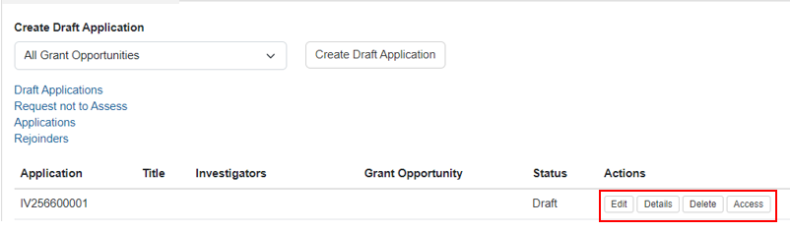

The Lead Entrepreneur should complete and submit the full application which will progress as per the application process.

**Note:** If the lead entrepreneur is unable to see the draft application the lead organisation may have not yet created it, the application may not have been found successful, or the outcome may not have been announced.

### Application overview

There are 5 parts (A – E) in the AEA Innovate application form:

* + A) administrative summary
  + B) business case
  + C) budget and financial information
  + D) personnel
  + E) partner organisations.

When the application has been created, the application form parts will be displayed at the top of the screen. The colour of these parts will be red indicating that the part is incomplete (invalid). When the application form parts have been completed, they will turn green (valid). Click on the relevant form part at the top of the screen to navigate between form parts (Part A to Part D)

Part E will appear once a partner organisation has been listed at question A3

Click on Part A to start filling in the application form

Move through the sections and enter the information of your grant

**RMS does not autosave your application. It is important to periodically save all changes. The ‘Save’ button is located at the top of the page next to the Adobe PDF file icon:**

**Note:** There is help text provided within the form to assist in completing questions. To access help information, click on the  icon.

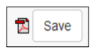

### Part A – Administrative Summary

#### A1 – Project Title

Provide a short title (up to 200 characters or approximately 25 words). The proposal title:

* should be an accurate reflection of the project
* avoidthe use of acronyms and **should not** use all upper-case characters
* may be modified and used for public release.

#### A2 – Domestic Participating Organisations Summary

Add all organisations participating in this proposal. Select the relevant ‘Organisation Role’ from the drop-down list:

* enter the name of the organisation in the search box and click ‘Search’
* select the relevant organisation from the list of search results and click 'Add’.

The following organisations, as per the AEA Innovate Program Administrative Guidelines, can be added to the proposal:

|  |  |
| --- | --- |
| One lead organisation | Lead organisations must meet the eligibility criteria specified under section 2 of the AEA Innovate Program Administrative Guidelines. It is a mandatory requirement to have a lead organisation and only one is allowed per proposal. |
| Collaborating Organisation/s | Collaborating organisations must meet the eligibility criteria specified under section 2 of the AEA Innovate Program Administrative Guidelines.  Collaborating organisations cannot be listed as the lead organisation on a proposal. Including a collaborating organisation is optional. |
| Partner Organisation/s | Partner organisations must meet the eligibility criteria specified under section 2 of the AEA Innovate Program Administrative Guidelines.  The applicant must nominate a partner organisation.  Partner organisation/s must provide a signed Partner Organisation Declaration Form (template available from Appendix C in the AEA Innovate Program Administrative Guidelines), to be uploaded at Question E1. |

#### A3 – Person Participant Summary

Add all people participating in this proposal as a lead entrepreneur, collaborating entrepreneur, or partner entrepreneur(see AEA Innovate Program Administrative Guidelines for definitions).

|  |
| --- |
| **Important:** Please note the completion of this question is dependent on the acceptance of invitations and the completion of question D2. Until all named applicants have accepted their invitations to the online RMS application and completed D2, Section A will not turn green. |

Select the relevant ‘Participation Type’ and enter the participant’s registered RMS email address, then click on ‘Add’. Repeat this action for the rest of the participants.

**Important:** ‘Person Profile’ details (personal details, qualifications, and employment) will be automatically populated into the online RMS application form and must be current at the time of submitting the proposal**. It is important that each participant has reviewed and updated their Personal Profile in RMS before completing this question**.

The following participants, as per the AEA Innovate Program Administrative Guidelines, can be added to the proposal:

|  |  |
| --- | --- |
| One lead entrepreneur (LE) | In accordance with Section 2.4 of the AEA Innovate Program Administrative Guidelines, to be eligible for the AEA Innovate Grant, proposals must “nominate an individual engaged by the grant recipient (Lead Entrepreneur) to work on the project over the grant period”. It is a mandatory requirement to have a lead entrepreneur and only one is allowed per proposal. Refer to guidelines for additional eligibility criteria.  Collaborating and partner entrepreneurs cannot be the lead entrepreneur. |
| Collaborating Entrepreneur/s | Collaborating entrepreneurs must meet the eligibility criteria specified under Section 2.4 of the AEA Innovate Program Administrative Guidelines and must be affiliated with a lead or collaborating organisation.  It is optional to have a collaborating entrepreneur. However, if listed, their names and their organisation need to be provided in the proposal, along with details outlining their role. |
| Partner Entrepreneur/s | Partner entrepreneurs must meet the eligibility criteria specified under Section 2.4 of the AEA Innovate Program Administrative Guidelines.  It is optional to include a partner entrepreneur in a proposal. However, if a partner entrepreneur is listed, their names and their organisation need to be provided in the proposal, along with details outlining their role. |

#### A4 – National priority area

**Note:**

* When a participant is added to the online RMS application, they will receive an automated email invitation and will be required to accept this invitation to participate in the proposal. When adding a participant, it is important to use the email address associated with their RMS account, so they receive an invitation to participate in the proposal.
* If the proposed participant does not have an RMS user account, they can request one by using the link found on the [RMS Homepage](https://aea_education.researchgrants.gov.au/RMS/ActionCentre/Account/RegisterUser).
* For instructions on how to provide access to the online RMS application form for a non-participant, see the [RMS User Guide - Submitting an application in RMS.](https://www.arc.gov.au/grants/rms-information)
* If a participant fills out the online RMS application form and then changes their role (e.g., from Lead Entrepreneur to Partner Entrepreneur), this may result in some questions in the form being cleared and made inactive to suit the new role, and other questions which were formerly inactive now being made active and requiring a response.
* Applicants should carefully check the online RMS application after any role changes are made. It is strongly encouraged to have defined a participant’s role prior to commencing the online RMS application form.

For AEA Innovate, consideration will only be given to projects addressing selected national priority areas. Please choose one priority area from the drop-down list. This information will be used for future reporting purposes if this proposal is funded. Please refer to the Department of Industry website for further information regarding the [National Reconstruction Fund Priorities (industry.gov.au).](https://www.industry.gov.au/news/national-reconstruction-fund-diversifying-and-transforming-australias-industry-and-economy)

#### A5 – Additional national priority area

If your project addresses more than one Government identified priority area, please select one other Priority area from the drop-down list below.

#### A6 – Focus Areas

Please select an option in the drop-down menu. Listed are the Focus Areas that will be prioritised during this round of Innovate. If your project does not fall under one of these categories, please select the ‘None of the above’ option. Being related to these focus areas is NOT an eligibility requirement.

Please provide an explanation of how the innovation is aligned to the above focus area (up to 1250 characters).

#### A7 – Project Objectives

The objectives should demonstrate what will be achieved by the end of the grant (up to 1000 characters, or approximately 150 words, per objective). Please explain your project’s objectives against AEA Innovate outcomes.

* List up to 4 key objectives specific to your project by clicking 'add answer' to add the next objective.

This information will be used for future reporting purposes if this application is funded.

#### A8– Public Project Summary

Provide a brief public project summary for members of the general public. Focus on the aims, significance, expected outcomes and benefits of this project (up to 1,500 characters or approximately 250 words).

* Write simply, clearly and in plain English.
* If the project is successful, the Project Summary will be used to give the general community an understanding of the project.

#### A9 – Technical Project Summary

Provide a project summary, focusing on the aims, significance, expected outcomes and benefits of this project (up to 1500 characters or approximately 250 words).

* Write the technical project summary simply and clearly.
* Avoid the use of acronyms, quotation marks and unnecessary upper-case characters.

#### A10 – Proposed Length of Project

Projects must be between 3 months to 24 months in total duration.

A drop-down box will provide options between 3 and 24 months to choose from. Please select the correct project length.

#### A11 – ANZSIC

Select one 3-digit code from the [Australian and New Zealand Standard Industrial Classification](https://www.abs.gov.au/statistics/classifications/australian-and-new-zealand-standard-industrial-classification-anzsic/2006-revision-2-0/numbering-system-and-titles/division-subdivision-and-group-codes-and-titles) that most aligns with the proposal. ANZSIC is a standard classification for the analysis of industry statistics. We are interested to know which industry will benefit if your project is commercialised and reaches the market.

Once you choose the ANZSIC code click on the 'Add' button.

#### A12 – Field of Research (FOR-2020)

Select up to three 6-digit [Field of Research (FOR) classification](https://www.abs.gov.au/statistics/classifications/australian-and-new-zealand-standard-research-classification-anzsrc/2020/anzsrc2020_for.xlsx) (FOR-2020) codes that relate to the proposal. The classification defines research according to disciplines. The FOR codes selected should reflect the nature of the research in this proposal, particularly if it is interdisciplinary.

When entering FOR codes:

* use descriptors or numeric codes to search for FOR code
* select up to 3 classification codes that relate to the proposal. Enter in the percentage for each FOR classification. Once you choose the FOR code click on the 'Add' button.
* prioritise the classification codes from highest to lowest percentage
* ensure that the percentages total 100.
* enter a whole number, do not use the percentage sign (%).
* the highest percentage can only be entered for one FOR code (for example, 50 cannot be entered for two FOR codes).

**Note:** Select the 6-digit FOR codes from the list of the FOR Codes carefully, as they contribute to the identification of the most appropriate assessors for the proposal. The Department of Education recommends that ‘XXX99’ (not elsewhere classified) codes be used only as a last resort when there is no other appropriate code within the classification.

#### A13 – Socio-Economic Objective (SEO-2020)

Select up to three SEO classification codes (SEO – 2020) that relate to the proposal. The [Socio‑Economic Objective (SEO) classification](https://www.abs.gov.au/statistics/classifications/australian-and-new-zealand-standard-research-classification-anzsrc/2020/anzsrc2020_seo.xlsx) indicates the sectors that are most likely to benefit from the project if funded.

When entering SEO codes:

* use descriptors or numeric codes to search for the SEO code
* select up to three classification codes that relate to the proposal. Enter in the percentage for each SEO classification. Once you choose the SEO code click on the 'Add' button
* prioritise the classification codes from highest to lowest percentage
* ensure that the percentages total 100
* enter a whole number, do not use the percentage sign (%)
* the highest percentage can only be entered for one SEO code (for example, 50 cannot be entered for two SEO codes).

#### A14 – Current Technology Readiness Level

Please provide details of the technology/solution’s current state of development, overview of the R&D completed thus far, project momentum and explanation for confidence in the potential of the solution. Select the current [Technology Readiness Level (TRL)](https://www.dst.defence.gov.au/sites/default/files/basic_pages/documents/TRL%20Explanations_1.pdf) for the project. For AEA Innovate, the starting TRL stages are between 5 and 7.

Use the drop-down box to select the current TRL for the project. Use the explanation text to articulate the current TRL.

#### A15 – Anticipated Technology Readiness Level

Please provide details of the technology/solution’s anticipated state of development, overview of the R&D to be completed, project momentum and explanation for confidence in the potential of the solution. Select the [Technology Readiness Level (TRL)](https://www.dst.defence.gov.au/sites/default/files/basic_pages/documents/TRL%20Explanations_1.pdf) to which you anticipate the grant will progress the project.

There is no requirement for AEA Innovate proposals to increase the anticipated Technology Readiness Level of a project by completion. However, if it does not expect to increase the anticipated Technology Readiness Level, the project must demonstrate progress within the Technology Readiness Level.

Use the drop-down box to select the Technology Readiness Level to which the grant will progress the project. Use the explanation text to articulate the anticipated Technology Readiness Level or the expected progress within the Technology Readiness Level.

**Note:** For the avoidance of doubt, AEA Innovate projects can progress to a TRL beyond 7 at the end of the grant.

#### A16 – How many research students will contribute to this project?

For reporting purposes, the AEA is capturing the number of research students that will contribute to this project if successful. This includes research students not funded directly from an AEA Innovate grant.

Select the number of students for *each student category* (full-time equivalent) that will be filled as a result of this project, not just those requested in the budget for funding in the online RMS application form e.g. Honours: 1, Masters: 0, or PhD: 2. Answers can be provided down to one decimal place.

#### A17 – How many research students will be funded from this grant?

For reporting purposes, the AEA is capturing the number of research students that will be funded by this grant if the project is successful.

Select the number of students for *each student category* (full-time equivalent) that will be funded by this grant if the project is successful, e.g., honours: 1, masters: 0, or PhD: 2. Answers can be provided down to one decimal place.

#### A18 – How many employees (full-time and part-time) are expected to be employed for the duration of the project?

For reporting and evaluation purposes, the AEA is capturing the number of people employed that will be funded by this grant if the proposal is successful.

Select the number of employees for each category (full-time/part-time) that will be funded by this grant if the proposal is successful e.g., Full-Time: 5, or Part-Time: 2

#### A19 – Where are the primary facilities for this research located?

Indicate the state/territory and postcode for the primary facilities where this research will be conducted.

* If there are multiple locations, please list them as secondary locations alongside their postcodes.
* This list should include locations of collaborating and partner organisations, wherein research is being conducted.
* Use the text box to indicate the primary research activities being undertaken at these facilities. Use the drop-down box to indicate if the research will be conducted at a regional campus.

#### A20 – Does this project involve interdisciplinary research?

This is a 'Yes' or 'No' question. If you select ‘Yes’, 2 additional questions will be enabled:

* specify the ways in which the research is interdisciplinary by selecting one or more of the options and click ‘Add’.
* indicate the nature of the interdisciplinary research involved (up to 1200 characters, approximately 200 words).

#### A21 – Does the proposed research involve international collaboration?

This is a 'Yes' or 'No' question. If you select ‘Yes’, two additional questions will be enabled:

* specify the nature of the international collaboration by selecting one or more of the options below.
* use the text box to indicate the nature of the international collaboration involved (up to 1200 characters, approximately 200 words).

#### A22 – If the project activity involves international collaboration, please specify the country/ies involved.

Indicate the countries involved in the international collaboration. Start typing in the search box and select from the drop-down list the name of the country/ies of collaborators who will be involved in the proposed project.

Note that Australia is not to be listed and is not available to be selected from the drop-down list.

### Part B – Selection Criteria

#### B1 – Selection Criteria

Upload your response to the selection criteria as a PDF file of no more than 15 pages with a limit of maximum 2 pages for each selection criterion, using the Selection Criteria template located on the AEA Website. Ensure that your text is readable both online and in print. For this reason, 11-12pt font is recommended.

Applicants should ensure that information provided addresses the selection criteria as detailed in section 4.2 of the AEA Innovate Program Administrative Guidelines.

#### B2 – Project Management Plan

Please upload completed project management plan (PMP) as a PDF file. For PMP template please visit the AEA website.

### Part C – Budget and Financial Information

#### C1 – What is the proposed budget for your project?

Outline the budget proposed for the project.

Ensure that your budget complies with the requirements of the AEA Innovate Program Administrative Guidelines. It is important that all participating organisations and entrepreneurs have been added to the online RMS application prior to commencing information in the budget table.

Funding must only be requested for eligible expenditure. Refer to the AEA Innovate Program Administrative Guidelines Section 3.1 for further information on eligible budget items.

Ensure that the funding is requested at the correct level as the AEA will not provide additional funds to cover a budget that has not been planned adequately. For AEA Innovate Grants, the maximum grant funding is up to a total of $5 million dollars.

The budget should also show the level of matching contributor funding (in-cash and in-kind) at least equal to the level of Commonwealth grant funding requested. The AEA also reserves the right to determine the level of funding allocated to a project.

Cash and in-kind (goods, services, and transactions not involving money) for each organisation should be shown.

Categorise items using the following headings:

* Personnel
* Expert Services
* Travel - Domestic
* Travel - International
* Plant & Equipment
* Other.

**Note:** Do not include GST in your costs.

#### C2 – Budget Explanation – AEA, Lead Organisation

Detail the ways in which funds from AEA Innovate and Lead Organisation, are proposed to be spent and explain any institutional overheads and on-costs. Outline separate answers for each organisation. Please note:

* Use the budget categories specified in C1 as headings.
* Justify each budget item requested in terms of need and cost.
* Justify any funding being requested for major items of equipment. Requests for major items of equipment are considered on merit. The participant should plan to use existing equipment wherever possible. If the participant is seeking funding for new equipment, describe how the equipment will be used and supplied.
* Requests for funding to cover the costs of domestic and international travel, including for reasons of fostering and strengthening collaborations in Australia and overseas, must be justified in full.

#### C3 – Previous funding for this project (non AEA grant funding)

Have you received prior funding for this research? If ‘yes’, please provide:

* funding project id
* name of funder and funding source (e.g. Commonwealth Government)
* project title
* total amount
* detail regarding how this grant will differ from previous funding for this research.

#### C4 – Have you previous applied for any AEA grants?

Have you previously applied for AEA funding for this or similar research? If yes, please provide:

* previous application number
* did you receive funding?
* Indicate which applications were funded.

### Part D – Personnel

**Important**: For all questions relating to **Part D**, please ensure that the information you provide is true and correct. Please note that any wilful dishonesty may **render the proposal being removed** from the process.

#### D1 – Entrepreneur

**This data is automatically populated from the participant’s RMS profile.**

Questions in a participant’s person profile can only be answered by the respective participant. The lead organisation will not be able to edit this information on behalf of participants.

To update the ‘Personal Details’ section, click on the ‘Manage Personal Details’ link. Note this will open a new browser tab. When returning to the form ensure to ‘Refresh’ the page to capture the changes made to the participant's profile.

The following data is automatically populated from the candidate’s RMS profile into the online RMS application:

* participation type
* title, first name, middle name, family name, phone number, email address, date of birth, country of birth, gender, citizenship, Australian residency, languages other than English, Indigenous status
* material personal interest questions as follows:
* Are you currently receiving any financial support (cash or in-kind) for research related activities from a country other than Australia?
* Are you currently, or have you previously been, associated or affiliated with a talent recruitment program from a country other than Australia?
* Are you currently associated or affiliated with a government, intelligence organisation, government owned enterprise, military, or police organisation in a country other than Australia?
* Have you identified and disclosed any conflicts of interests in accordance with your Institution’s conflict of interest policies and procedures? This question serves as a declaration that:

1. You have one or more conflicts of interest (COIs) and have disclosed them to your employing institution, and if relevant, lead organisation(s) of Department of Education grant proposals as required by the institution(s)'s COI policies and procedures; or
2. You do not have any COIs and have followed the relevant institution(s)'s COI policies and procedures (which may include reporting you have nil COIs).

In both cases you should answer 'Yes' to this question.

A 'No' answer to this question indicates that you have a COI that you have not disclosed to your employing institution or relevant Lead Organisation(s) of Department of Education grant proposals. In this case you will be prevented from participating on a Department of Education grant proposal.

* Has the participant acknowledged the collection of personal information by the Department of Education?

For the online RMS application form to become valid the participant must acknowledge the collection of personal information within the profile.

**Important:** If an applicant fails to appropriately fill out this information this will not be populated into the online RMS application form and may result in ineligibility.

**Note:** The phone number, date of birth, country of birth, citizenship, material personal interests, and Indigenous status responses will not be visible to the expert advisors assessing proposals. However, all information contained in Part D is visible to the Lead Organisation and project participants on this proposal, as well as the department.

#### D2 – Eligibility – Organisation applicant is engaged with at the commencement of this project

Enter the organisation that you are/will be engaged with at the commencement of your participation in this project. Note that the organisation must be listed in question A3 for this question to validate.

The ‘relevant organisation’ is the primary organisation that will be supporting your involvement in this project if it is funded.

#### D3 – Qualifications

This data is automatically populated from the participant’s RMS profile.

Questions in a participant’s Person Profile can only be answered by the respective participant. The lead organisation is not able to edit this information on behalf of participants.

To update any qualifications, click on the ‘Manage Qualifications’ link. Note this will open a new browser tab. When returning to the form ensure to ‘Refresh’ the page to capture the changes made to the participant's profile.

#### D4 – Career Stage

This question will be a drop-down menu where each listed personnel on the proposal can indicate their career stage as it will be at the commencement of the project. Each applicant will need to choose one of the following as their career stage:

* student (undergrad/master/PhD)
* research assistant
* early career researcher
* mid-career researcher
* established career researcher
* partner entrepreneur.

Non-academic partners can be listed as ‘research assistant’ or may select a suitable equivalent to their level of professional experience. For Partner Entrepreneurs please select partner entrepreneur from the list.

#### D5 – What will your time commitment be to research activities related to this project?

Each participant’s time commitment to this project should be entered as a full-time equivalent (FTE).

**Note:** An FTE of 1.0 represents a full-time commitment (i.e., 5 days per week).

#### D6 – 10 Year Employment History

This data is automatically populated from the participant’s RMS profile.

Questions in a participant’s person profile can only be answered by the respective participant. The lead organisation is not able to edit this information on behalf of participants.

To update any employment history, click on ‘Manage Employment Details’ link. Note this will open a new browser tab. When returning to the form ensure to ‘Refresh’ the page to capture the changes made to the participant's profile.

#### D7 – ORCID link

ORCID (Open Researcher and Contributor ID) is an open, non-profit, community-driven effort to create and maintain a registry of unique researcher identifiers and a transparent method of linking research activities and outputs to these identifiers.

Please provide a link to the participant’s ORCID profile, e.g., <https://orcid.org/0000-0000-0000-0000>.

#### D8 – Research Outputs – (up to 10 most relevant research ouputs/projects)

The data is populated from the ‘Research Outputs’ section within the participant’s RMS profile. The participant will have the flexibility to choose and add which outputs to include in the proposal.

Provide a list of the 10 most relevant research outputs/projects relevant to this proposal (up to a maximum of ten). To indicate the ten most relevant research outputs to this proposal, enter numbers 1 up to 10 in the ‘Rank’ column. To indicate research outputs that are relevant, tick the 'Relevant' checkbox which will add an asterisk against that research output. To add an additional output, please select ‘add’ each time.

**Note:** RMS will not prevent the entry of duplicate records and it is the responsibility of applicants to manage this. Users will have the flexibility to choose research outputs for listing in their grant proposals. For instruction on how to add research outputs to a user’s profile in RMS, refer to the [User Guide: Research Outputs in RMS](https://www.arc.gov.au/sites/default/files/2022-09/User%20Guide%20Research%20Output%20Instruction.pdf) available on the ARC website.

Only ten research outputs should be listed. Any additional outputs included will not be considered.

#### D9 – Research Outputs Context

This section gives context to a participant’s research experience and provides an opportunity to further explain periods of research and non-research employment, and career breaks.

The information should help assessors understand the context of the participant’s academic research achievements but not repeat information already provided in this proposal.

Provide clear information that explains the relative importance of different research outputs and expectations in the participant’s discipline/s.

It is helpful to include the importance/esteem of specific journals in their field; specific indicators of recognition within their field such as first authorship/citations, or significance of non-traditional research outputs.

If this question is not relevant to a participant, for example a partner entrepreneur with a ‑non-academic background, the participant should include a short explanatory statement as to why this question is not applicable. (Up to 3,750 characters, approximately 600 words).

#### D10 – Commercialisation and Industry Collaboration Experience

Provide a short description of your commercialisation and industry collaboration experience, including relevant professional development undertaken in the past 10 years. For example, have you participated in any commercialisation programs (such as [CSIRO's ON program](https://www.csiro.au/en/work-with-us/funding-programs/innovation-programs))?

#### D11 – Conflict of Interest (COI)

Do you have any actual, perceived or potential conflicts of interest in relation to any aspect of the application/ project in accordance with your Institution’s conflict of interest policies and procedures?

In accordance with the Ignite Program Administrative Guidelines, each individual or organisation named in an application must declare any actual, perceived, or potential conflict of interest that exists within and outside Australia, is likely to arise, or does arise in relation to any aspect of the application or project to the applicant for inclusion in the application.

#### D12 – Certification by Participants

The participant is required to provide certification of all relevant clauses. The certification includes the review and confirmation of the accuracy of all information contained in the proposal, including information entered within the participant’s Person Profile.

The online RMS application form will not validate if ‘No’ is selected.

#### D13 – Certification by Lead Organisation

The lead organisation is required to provide certification of all relevant clauses. The certification will only appear to lead organisation delegates once the form has been submitted to the lead organisation by the lead entrepreneur. The certification will not appear in the online RMS application form.

The online RMS application form will not validate if ‘No’ is selected.

### Part E – Collaborating and Partner Organisation

Collaborating and Partner organisation/s are auto-populated from question A3.

#### E1 – Partner Organisation ABN

Provide each Partner Organisation’s Australian Business Number (ABN). If you do not know your Partner Organisation’s ABN please use the ABN Lookup to find the relevant ABN. In AEA Innovate all listed Partner Organisation must provide a valid ABN.

#### E2 – Partner Organisation Declaration (POD)

**Upload a single Partner Organisation Declaration Form for each listed Partner Organisation.**

The Partner Organisation Declaration form is available in Appendix C of the AEA Innovate Program Administrative Guidelines. The declaration form reads:

To whom it may concern

I am writing on behalf of *[Partner Organisation]* to provide our support for the funding application: *[AEA Innovate Application Number] [AEA Innovate Application title].*

*Please use up to two pages to provide the details of:*

* *the Partner Organisation*
* *an overview of how the Partner Organisation will work with the other participating organisation/s to successfully complete the project*
* *an outline of the relevant experience and/or expertise the Partner Organisation will bring to the project]*

Total partner contributions over the Project funding term are listed below and are consistent with the total contributions listed in the application:

|  |  |
| --- | --- |
| **Contribution Type** | **Amount** |
| **Cash ($AUD) for grant period** | $ |
| **FTE (to two decimal points) for funding term (in-kind)** |  |
| **FTE ($AUD) for funding term (in-kind)** | $ |
| **Non-staff in-kind ($AUD) for funding term** | $ |

**Note:** a business partner organisation may elect to participate in an Innovate project for less than the full project duration.

**Declaration**

On behalf of *[insert Partner Organisation]* I declare that, should this application be successful, the Partner Organisation:

* Is aware of the requirements related to Partner Organisations under the AEA Innovate Program Administrative Guidelines.
* Will support and actively participate in the proposed AEA Innovate project.
* Will contribute the staff, funds and other resources indicated in the application and has obtained, or will obtain, the necessary authorisations to do so.
* Confirms that cash contributions are not sourced from Commonwealth Government funds for the purposes of research, including the Research and Development Tax Incentive (R&D Tax Incentive or R&DTI).
* Will comply with and require that its subcontractors and independent contractors comply with, all applicable laws.
* Information contained in this application, together with any statement provided, is to the best of my knowledge, true, accurate and complete. I also understand that the giving of false or misleading information is a serious offence.
* Acknowledges that if the department is satisfied that any statement made in an application is incorrect, incomplete, false, or misleading, the department may, at its absolute discretion, take appropriate action.
* Understands that they may be requested to provide further clarification or documentation to verify the information supplied in this form and that the department may, during the application process, consult with other government agencies, including State and Territory government agencies, about the Lead Organisation’s claims and may also engage external technical or financial advisers to advise on information provided in this form and the application.
* Provides consent to be contacted by the department to discuss the particulars of the partner’s commitment to the proposed Innovate project.
* Approves of the information in this form being communicated to the department in electronic form.

**Signing**

By signing below, I agree that I am authorised to sign and submit this declaration on behalf of the Partner Organisation and confirm all the above statements to be true.

|  |  |
| --- | --- |
| **Partner (organisation name):** |  |
| **Partner ABN:** |  |
| **Authorised representative (name):** |  |
| **Position/role:** |  |
| **Phone:** |  |
| **Email:** |  |
| **Signature:** |  |
| **Date:** |  |

#### E3 – Partner Organisation’s ASIC documentation

Upload a single ASIC document per listed partner organisation. Each upload should describe the nature of the organisation’s structure and ownership and include:

* current and historical company information
* roles and relationship extract
* capitalisation (CAP) table for each partner organisation.

#### E4 – Budget Explanation

Detail the ways in which funds (both cash and in-kind) from this partner/collaborating organisation/s are proposed to be spent and explain any institutional overheads and on-costs.

* use the budget categories (Part C) as headings.
* provide details including what each participant will contribute to the project in relation to their time and any other contribution of their organisation.
* if there is no direct funding being provided by a participating organisation in cases where this could reasonably be expected, explain fully why no commitment has been made.

## Contact and Further Information

For enquiries about AEA Innovate, applicants should seek advice from their institutional research office (or equivalent). Research office staff can email accelerator@education.gov.au for further advice if queries cannot be answered by the Program Administrative Guidelines, Applicant’s Guide, or Frequently Asked Questions.