****-+Australian Government
Australia's Economic Accelerator

2024-25

Annual Report

on research translation

and commercialisation

Australia’s Economic Accelerator (AEA) Advisory Board



With the exception of the Commonwealth Coat of Arms, the Department’s logo, any material protected by a trademark and where otherwise noted all material presented in this document is provided under a Creative Commons Attribution 4.0 International (https://creativecommons.org/licenses/by/4.0/) licence.

The details of the relevant licence conditions are available on the Creative Commons

website (accessible using the links provided) as is the full legal code for the CC BY

4.0 International (https://creativecommons.org/licenses/by/4.0/legalcode)

The document must be attributed as the *AEA Advisory Board 2024-25 Annual Report*.

Contents

Acknowledgement of Country 2

Letter to the Minister for Education 3

Foreword from the Chair 4

About AEA 5

The Current Environment 7

Streams of Research Commercialisation and Innovation Programs 10

The Board and the Priority Managers 12

Board members 12

Priority Managers 15

Achievements and Outcomes 17

AEA Seed 17

AEA Ignite Round 1 20

AEA Innovate Round 1 22

The Research Commercialisation Strategy 22

The Investment Plan 23

Barriers 25

Appendices 26

Appendix A: Board member’s terms of appointment 26

Appendix B: Corrigendum 26

## Acknowledgement of Country

The Department of Education acknowledges the Traditional Owners and Custodians of Country throughout Australia and their continuing connection to land, waters and community. We pay our respects to them and their cultures, and Elders past and present.

## Letter to the Minister for Education

Dear Minister

In accordance with Section 42–20 of the *Higher Education Support Act 2023* (HESA), I present the 2024–25 Annual Report on behalf of the members of the AEA Advisory Board. This report covers the activities of the Board and the operations of AEA in 2024–25.

AEA supports research translation and commercialisation aligned to the Government identified priority areas of the economy (outlined in the *National Reconstruction Fund Corporation (Priority Areas) Declaration 2023*). To ensure AEA investment drives the best possible outcomes, the Board’s Annual Investment Plan 2025–26 identifies 8 focus areas of high commercial opportunity and research strength, underpinned by a robust methodology, to guide AEA investment decisions. This approach taken is responsive to key Government policies, particularly the National Science and Research Priorities, Future Made in Australia, Circular Economy, Net Zero and Sovereign Defence Industrial Priorities.

For each focus area, the Investment Plan provides key data around research strength, research translation potential, market size, and strategic alignment with areas of national priority that have informed their selection.

More than $178 million has now been awarded to Australian innovators through AEA Seed, Ignite and Innovate rounds as part of the $1.6 billion AEA program (2023 – 2032). These projects are part of a broader push to fast-track commercialisation of Australian research in critical areas like renewables, agriculture, medical technology, defence and critical minerals.

The *Olives the Australian Way* project from the University of South Australia is an example of these projects in action. Starting in the Seed round and now progressing to Innovate, the project aims to double Australia’s olive plantations by 2035 and create new jobs in rural and regional areas. These investments allow our world-class universities and researchers to work on game-changing projects that are good for our economy and good for Australia.

The Board and the Department of Education have had rich discussions on AEA with stakeholders across government, and with universities and researchers, investors, and industry that have informed our current approach. Our engagement with stakeholders will continue as the Board’s approach will need to evolve over time to maintain the currency and relevance of AEA in the research ecosystem.

I look forward to working with you over the next year delivering solutions we need for the challenges ahead.

**Mr Jeff Connolly**

Chair of the AEA Advisory Board

## Foreword from the Chair

As Chair of the Australia’s Economic Accelerator Advisory Board, I am pleased to present the AEA Annual Report for 2024–25.

This report details the progress that has been made over the last financial year and provides an overview of the activities of the Board in 2024–25.

AEA has made significant gains in accelerating reform in the higher education sector through targeted investment into Government identified priority areas for the economy. AEA has adapted to emerging trends and market conditions to ensure that the program is responsive to the changing needs of industry and communities.

AEA operates within a broader suite of other research commercialisation programs including Trailblazer Universities, National Industry PhD program, Main Sequence, CSIRO ON and the National Collaborative Research Infrastructure Strategy (NCRIS). While AEA is distinct in its fast-fail approach and driving commercial outcomes, these programs are underpinned by a shared commitment to amplifying connections between industry and research and shifting the dial to increase translation and commercialisation of Australian research. The Board continues to engage meaningfully with stakeholders across these programs to build collaboration and share expertise.

Alongside these programs, the Government appointed a panel of experts to complete a strategic examination of Australia’s R&D system. There was a strong response to the public consultation on this project, with almost 500 submissions and more than 600 stakeholders attending roundtables and webinars discussing the untapped potential for Australia to lead research and development.

In June 2025, the Board released the AEA Annual Investment Plan for the financial year ahead (2025–26) outlining new focus areas that have been identified through extensive analysis of technology and market conditions, including space technologies and renewable energy, as well as broadening digital agriculture to encompass agriculture and food technology. Over the course of the year, AEA successfully delivered the first rounds of Ignite and Innovate funding streams, with a total of $153 million in funding awarded. The seed grants awarded in 2023 have already began delivering results and are demonstrating real commercial viability and maturity. These projects are breaking through barriers and transforming innovation for the benefit of all Australians.

It has been an honour to chair the AEA Advisory Board over the past financial year. I want to thank each Board member for bringing the full weight of their knowledge and experience to the challenge of advising Government on research innovation and translation. I would also like to thank the Department of Education for their professionalism and support of the Board.

**Mr Jeff Connolly**

Chair of the AEA Advisory Board

## About AEA

Australia’s Economic Accelerator (AEA) was established in 2022 as a research funding program designed to shift the dial on Australian research, by supporting the translation and commercialisation of our world-leading research in the university sector. The program supports a culture shift to improve collaboration between universities and industry, to commercialise university research in areas where Australia has strong competitive advantage and that solves domestic and global market needs.

AEA is one of a suite of programs that helps create a research ecosystem where our worldclass research is translated into innovations to serve real world market needs and deliver productivity and economic gains. The objectives of the AEA, the Trailblazer Universities Program and the National Industry PhD program align with the Australian Government’s Future Made in Australia agenda.

As a priority-driven grant program, AEA supports projects aligned with national research priorities with high commercial opportunity. Funding is available to universities, and applicants are required to partner with industry.

AEA is designed to attract projects at a proof-of-concept or proof-of-scale level of commercial readiness that have high commercial potential (Figure 1). Projects can come into the program at any stage, or progress through the program based on continued success and achievement of milestones that validate the commercial potential and path to commercial product. To reflect the increasing costs associated with later-stage development, the amount of AEA funding increases as projects mature towards at-scale commercialisation.

The Main Sequence fund provides a high-value opportunity for projects that successfully progress through the AEA. Other Australian Government funding sources include the Clean Energy Finance Corporation and the National Reconstruction Fund (NRF). Strategic business partners and venture capital investment are also important sources of private follow-on funding for AEA grantees.

Industry participation is critical to the success of the program. Examples of industry involvement include embedded industry experts, in-kind support, formal collaborations or partnerships, and investment.

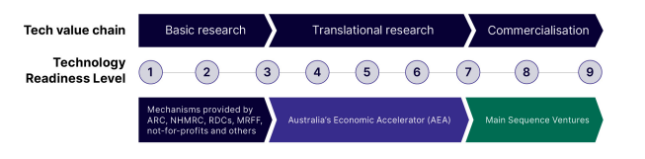**Figure 1. AEA is designed to bridge the gap between basic research and commercialisation**

AEA is governed by an Advisory Board, supported by expert Priority Managers. Board members have experience and knowledge in research and its translation and commercialisation, and represent government, industry and research sectors. Priority Managers are highly qualified, experienced, and motivated business and technology specialists. Priority Managers support successful applicants to foster connections and secure formal collaboration arrangements with industry partners.

Distinct from other funding models in research, AEA will support the translation and commercialisation of the outcomes of university research in collaboration and partnership with industry. AEA fills a gap in the current research commercialisation landscape by funding the university sector to engage in translational research from early-stage research into products that are attractive for industry collaboration and investment and will have impact in major markets, thereby growing Australia’s economy

## The Current Environment

Australia has a strong track record in producing excellent scholarly research. By boosting our investment into R&D, we will ensure that our knowledge is translated into new products and innovations. In 2024, we accounted for 3% of the publications and 7% of citations, with 41% of our research in the top 10% of journals worldwide.[1] However, we underperform in terms of utilising the rich work of Australia researchers to create social and economic gain. Barriers affecting collaboration between academia and industry and declining investment in research and development (R&D) have impacted the commercialisation of the rich work of Australia researchers.

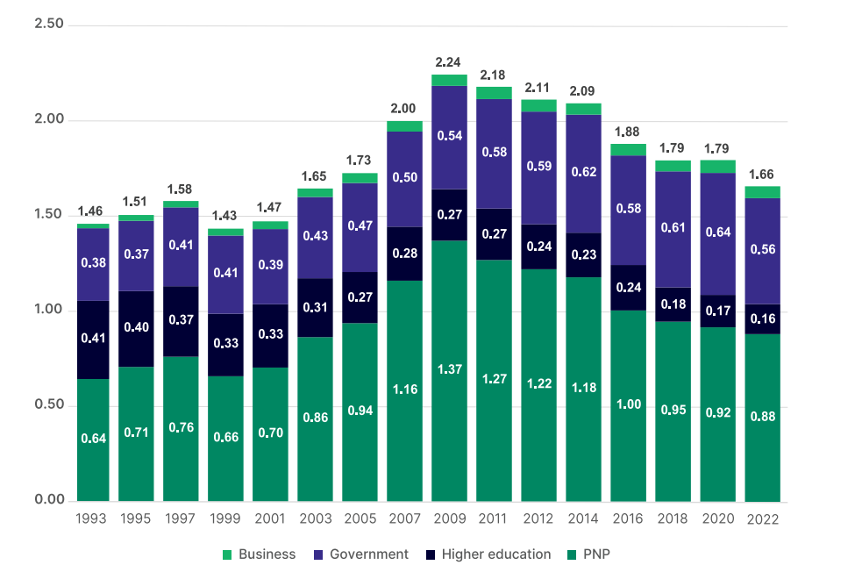**Figure 2. Australian expenditure on R&D by sector as a percentage of GDP**

Australia’s gross expenditure on R&D as a percentage of GDP has steadily declined from a peak of 2.24% in 2008–09 to 1.66% of GDP in 2021–22 which was significantly below the Organisation for Economic Cooperation and Development (OECD) average of 2.73%.[2] The key reason for this overall decline was the steady reduction in both business and government expenditure on R&D as a percentage of GDP over the same period. The higher education sector has been a strong contributor to R&D in Australia, accounting for 60% of basic research which is comparable to other OECD countries and 50% of applied research which is much higher relative to comparator countries in the OECD. However, low business R&D investment makes it difficult for applied research produced by the higher education sector to be translated and commercialised.

The [SERD Discussion Paper](https://consult.industry.gov.au/strategic-examination-rd-discussion-paper) (https://consult.industry.gov.au/strategic-examination-rd-discussion-paper) identifies a range of possible underlying factors impacting university-industry collaboration.[3] These include: insufficient incentives for academics to engage with industry to translate their research, a lack of diverse career pathways enabling researchers to work across sectors, lack of skills across both industry and academia in areas such as product development and technology transfer to support effective collaboration and translation, dominance of Australian industry by small businesses leading to capacity constraints on R&D investment, and the mismatch between industry’s need to quickly identify the commercial viability of innovations and academics’ focus on validating them first as further barriers to effective university-industry collaboration.

Australia’s economic growth has also slowed down due to reduced population growth and workforce participation while productivity has also declined over time. According to the Atlas of Economic Complexity, which ranks countries according to their ability to manufacture and export diverse and complex products and services and is considered a key predictor of future economic growth, Australia had the 9th highest GDP per capita out of the 145 countries considered, but had an economic complexity ranking of 105 in 2023, making it the OECD country with the lowest rank on this indicator (Figure 3).[4] Innovation is key to achieving greater economic diversity and raising productivity. According to OECD data, only around 14% of ‘product innovative’ firms in Australia introduced new-to-market innovations in 2020–21, placing us 20th among 34 OECD countries, while only 1–2% of Australian firms engage in novel innovation that stems from R&D.[5]

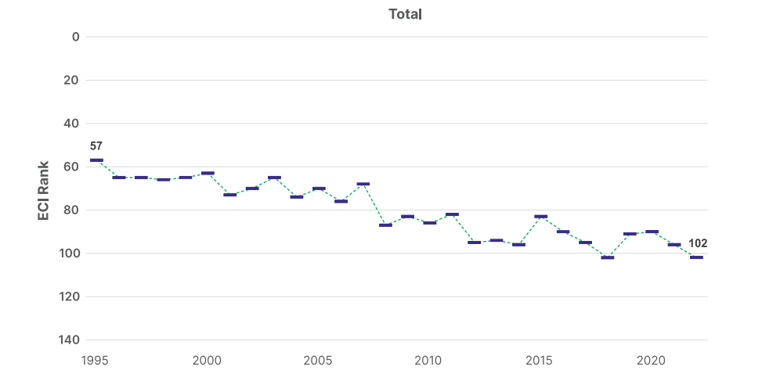**Figure 3. Australia’s economic complexity (Economic Complexity Index (ECI) ranking over time)**

The adoption of strategies to increase the uptake of R&D by all players in the innovation ecosystem and collaboration among them can help reverse these trends while also protecting our national interest, sovereignty, supply chains, and domestic capabilities. The Australian Government’s Research Translation and Commercialisation Agenda addresses this key challenge by placing university innovation and industry collaboration front and centre of Australia’s economic recovery.[6]

According to forward estimates from the Science, Research and Innovation budget tables of the Department of Industry, Science and Resources, Australia’s investment into R&D will exceed $14.4 billion in 2025–26, an increase of $6.5 million (a 0.05% increase) from R&D investment in 2024–25 and a $2.5 billion increase in government investment into R&D from 5 years ago in 2020–21 (a 20.9% increase).[7] The Education portfolio is a major contributor to this investment into Australia’s research sector, allocating over $4.3 billion into R&D activities in 2024–25 (30.1% of total Government R&D investment).

## Streams of Research Commercialisation and Innovation Programs

The AEA operates within a broader suite of other research commercialisation and innovation programs that aim to shift the dial to increase translation and commercialisation of Australian research. These other programs include:

#### The Trailblazer Universities Program

The Trailblazer Universities Program funds selected universities to transform how the higher education sector collaborates with industry, to accelerate the commercialisation of university research. The program incentivises flexible approaches to IP management and academic career progression, and industry leadership of research translation projects. The collaborations include projects like those funded by AEA. The program provides $370.3 million over four years from 2022–23 to 2025–26 to drive commercialisation outcomes and boost university collaboration with industry. Each Trailblazer university receives $50 million with matched funding by the lead university and their industry partners.

#### The Increase Workforce Mobility Initiative

The Department of Education, the Australian Research Council (ARC), and CSIRO are working together on the Increase Workforce Mobility Initiative: a $296 million initiative to build an industry-focused research workforce. The Increase Workforce Mobility Initiative supports the Trailblazer and AEA programs by helping research students build skills relevant to those programs. The initiative aims to strengthen partnerships between universities and industry, help researchers develop skills for collaboration and innovation, and support research that can be turned into real-world solutions. The National Industry PhD Program, ARC Fellowships, and CSIRO Industry PhD Program are included under this initiative.

#### Main Sequence

Main Sequence was founded by CSIRO in 2017 to boost research commercialisation by investing venture capital in spinouts, startups and SMEs connected to Australia’s publicly funded R&D sector. Main Sequence seeks to amplify connections between industry, research and infrastructure to accelerate deep technology development, and reinvesting economic returns from commercialisation back into the Australian economy. Recognising the success of government cornerstone investment in drawing private sector capital to the table and commercialising Australian investment, the Government provided CSIRO with $150 million for a commitment to Main Sequence Funds 3 and 4 through the University Research Commercialisation Action Plan. A successful $450 million Main Sequence Fund 3 raise brought funds under management to over $1 billion.

#### CSIRO ON program

The CSIRO ON Program is a series of initiatives designed to accelerate the commercialisation of Australian research breakthroughs. It helps researchers develop the skills and confidence to engage with business, drive uptake of their ideas, and validate innovative ventures. The program has delivered training and support to thousands of people, creating a legacy and vibrant community of researchers, founders, industry experts, advisors and investors that participants can lean into. More than 8,000 participants have been upskilled through ON programs and over $350 million in commercialisation grants have been attracted by ON alumni since inception.

#### National Collaborative Research Infrastructure Strategy (NCRIS)

NCRIS is a highly collaborative program which maximises Australia’s national research infrastructure investments by coordinating open access, targeted specialities, and co-funding across the country. The Government has invested $4 billion over 12 years (from 2018 to 2029) to support important pieces of national research infrastructure. National research infrastructure provides access to researchers and industry and supports the development of the research workforce. National research infrastructure underpins our national research effort and is essential to support breakthrough research discoveries, adapting to new technologies, and addressing global challenges.

## The Board and the Priority Managers

The Board is comprised of 8 members (a Chair, Deputy Chair and 6 members), who possess experience and knowledge in research and its commercialisation, and represent government, industry, business and research sectors. The AEA Advisory Board was appointed by the Minister for Education, the Hon Jason Clare MP, on 3 July 2024 for staggered terms of 3 and 5 years.

## Board members

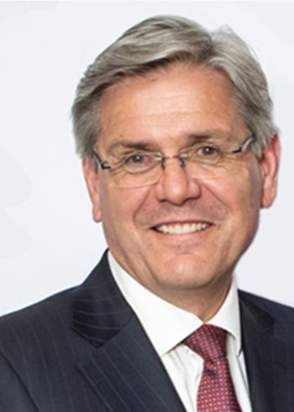**Mr Jeff Connolly**

**Chair**

Jeff Connolly has been appointed Chair of the AEA Advisory Board.

Jeff serves as Executive Director and CEO of Thales Australia, a premier provider of products, systems, solutions and services in the global defence, security, space, aerospace and civil digitalisation markets. With a background as the Executive Chairman and CEO of Siemens Australia and New Zealand, he is known for his leadership in advancing the uptake of automation and digitalisation technologies applied to Australian infrastructure, manufacturing and process industries. He chaired both the Australian Government’s Industry 4.0 taskforce and the University Research Commercialisation Scheme expert panel. Jeff was also an advisor to NSW Government’s Industry Policy White Paper. He has been appointed Chair of the AEA Advisory Board where he brings a wealth of experience in research translation and commercialisation related to the National Reconstruction Fund’s priority areas.

**Ms Julia Spicer OAM**

**Deputy Chair**

Julia Spicer OAM has been appointed as Deputy Chair of the AEA Advisory Board.

Julia brings a regional and small business perspective to her experience in research commercialisation and innovation. As Queensland Chief Entrepreneur, she dedicated herself to facilitating opportunities for regional Australia. A University of Queensland graduate with a background in environmental management, Julia is an active leader and mentor, contributing to various roles such as chairperson for Global Entrepreneurship Network Australia and director of The Goondiwindi Business Hub. She is passionate about community and industry growth, in support of the sustainability of regional Australia.

**Dr Angeline Achariya**

**Member**

Dr Angeline Achariya is a global leader in commercialising innovations in Agribusiness industries and currently leads as the CEO of Innovation GameChangers. Within her portfolio, Angeline is the Asia Pacific Chair of Food Systems Innovation & Resilience, G100 Mission Million. She holds board director roles with Nutrition and Catering Institute, Australian Food Science & Technology Institute, and senior advisor at Beanstalk Agtech. Angeline brings over 25 years’ experience in multinational giants such as J R Simplot, Mondelez International, Yum Brands, Fonterra, Mars Corporation and Monash University. As a member of the AEA Advisory Board, Angeline brings expansive knowledge in agriculture and food innovation with skills in research translation and commercialisation.

**Prof Mark Hutchinson**

**Member**

Professor Mark Hutchinson, Director of the Institute for Photonics and Advanced Sensing at Adelaide University, is a globally recognised medical scientist with a focus on neuroimmune research. Leading the foundation of numerous startups, he has received prestigious awards for his outstanding contributions. With a strong academic background from the University of Adelaide, Mark’s expertise extends to roles such as a member of the Prime Minister’s National Science and Technology Council, Chair of the Steering Committee for the Australian Pain Solutions Research Alliance, and Chair of the Safeguarding Australia through Biotechnology Response and Engagement (SABRE) Alliance. Mark brings a wealth of expertise in research commercialisation and innovation within the fields of medical science, agriculture, defence and enabling capabilities.

**Dr Paul Kelly**

**Member**

Dr Paul Kelly, an Australian physician and biotechnology entrepreneur, brings over 30 years of experience in developing and commercialising biomedical innovations in Europe, US and Australia. Prior to co‑founding Sydney based Venture Capital Firm, OneVentures in 2010, Paul led numerous successful ventures in the US including Gemini Genomics, Agamatrix and Atomera. As founding partner at OneVentures he leads the Healthcare investment team. Paul holds medical and Doctorate degrees from the University of New South Wales. His distinguished career in endocrinology at St Vincent’s Hospital, Sydney has led to serving on the boards of Garvan Institute of Medical Research, BiVacor, Prota Therapeutics, Clinical Genomics, Vaxxas, and Hatchtech. Paul brings a breadth of seasoned expertise in medical science and enabling capabilities with skills in investment and research translation and commercialisation.



**Dr Virginia Marshall**

**Member**

Dr Virginia Marshall is a Wiradjiri Nyemba woman and a Research Fellow at the Australian National University’s School of Regulation and Global Governance (RegNet). She is a practising lawyer and leading legal scholar with expertise in Aboriginal water rights, native title rights in Sea Country, Indigenous governance, and the intersection of Traditional Knowledge systems and western intellectual property regimes, especially in relation to traditional medicine research and development, and is Lead Chief Investigator on the Australian Research Council Discovery research project, Barriers and pathways to development of Indigenous traditional medicines. Virginia holds various government appointments, serving on the Climate Change Authority Board, Acting Chair of the Australian Government Department of Climate Change, Environment and Water’s Committee on Aboriginal Water Interests (CAWI) and on the Drafting Group for the National Water Initiative Mark 2.

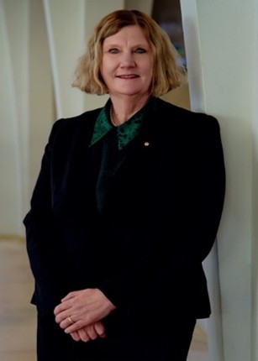**Ms Catherine Roberts AO CSC**

**Member**

As member of the AEA Advisory Board, Air Vice-Marshal (retired) Catherine (Cath) Roberts AO CSC has dedicated her career to innovation and stretching boundaries. She was Australia’s first Space Commander (2021–2023) and brings over 40 years of experience serving in the Royal Australian Air Force as an Aerospace Engineer. Cath has a passion for diversity in STEM through her work with Women in Aviation/Aerospace Australia, Women in Aviation International and has mentored in both the Future Through Collaboration (defence and industry) and Superstars of STEM programs. She is a Fellow of Engineers Australia, Member of Australian Institute of Company Directors, member of Defence SA Advisory Board and was a member of the Australian Space Agency Advisory Board from 2019–2023. In recognition of her achievements, Cath was awarded a Conspicuous Service Cross for her contribution to Aviation Safety in 2004 and appointed an Officer of the Order of Australia in 2022.

**Ms Lauren Stafford**

**Member**

As a member of the AEA Advisory Board, Lauren Stafford is a skilled practitioner in commercialisation and intangible asset strategy including human capital, data and intellectual property. She has 15-years’ experience in technology development and commercialisation in the resources sector. Lauren is currently the Director of Business Development at First Mode and formerly held leadership roles at Woodside Energy, BHP, Austmine and the University of Queensland. Lauren is a member of the Board of Industry Innovation and Science Australia and a member of the Research Infrastructure Advisory Board. Lauren brings strong commercialisation expertise and industry knowledge.

## Priority Managers

The Board is supported by a Lead Priority Manager (Executive Director) along with a team of Priority Managers who provide specialist technical advice on research commercialisation and act as conduits for university applicants, industry and potential end-users of research, and investors. They bring lived experience in innovation and research translation and commercialisation across the Government’s identified economic priority areas.

Priority Managers played a pivotal role in the successful delivery of the first round of AEA’s Ignite and Innovate grants. Their contributions included reviewing applications, developing training materials for AEA assessors, providing technical guidance to the Board’s Investment Sub-Committee (ISC), and helping to craft feedback for unsuccessful applicants. They also actively promoted AEA through targeted engagement at major industry events on research commercialisation, helping to raise awareness and strengthen stakeholder connections.

Priority Managers have a duty of care and diligence to act honestly and ethnically, in good faith, and to behave with integrity and discretion in the execution of their duties. As part of their role, Priority Managers disclose, and take reasonable steps to avoid, conflicts of interest in connection with their role.

Working closely with universities, industry and investors, Priority Managers play a central role in identifying investment and partnership opportunities for AEA, ensuring alignment with national priorities and maximising program impact.

**AEA Seed Cade Study**

**Revolutionising Radiation Protection**

**PRIORITY AREA > DEFENCE CAPABILITY**

**The University of Adelaide’s development of the first drug for multiorgan radiation**

**protection: $395,000**

Radiation exposure incurred during space exploration is one of the greatest threats to an astronaut’s health. That’s because the radiation environment outside of the Earth’s protective atmosphere is comprised of high-energy particles that pose a hazard to living organisms.

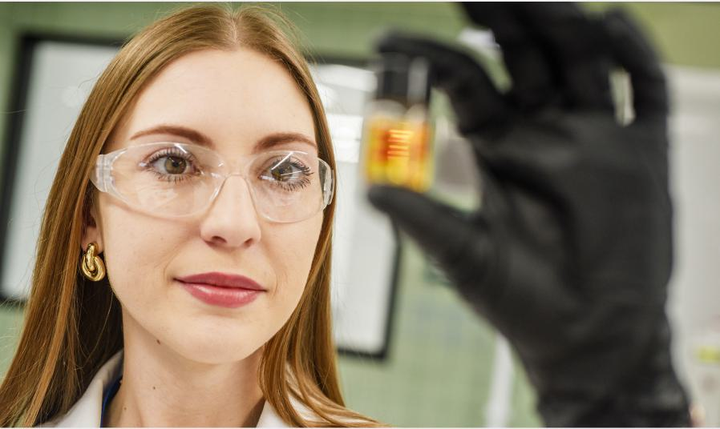Researchers from the University of Adelaide and the South Australian immunoGENonmics Cancer Institute (SAiGENCI) have now developed a pill that offers critical protection from the immediate and lasting impacts of radiation. Dr Agnieszka Kumorkiewicz-Jamro says extensive pre-clinical pharmaceutical studies of the pill have demonstrated promising results, with potential uses for the space, defence and mining industries, and for cancer treatment.

Project Lead Entrepreneur Dr Agnieszka Kumorkiewicz-Jamro in the University of Adelaide Laboratory

### Achievements and Outcomes

In July 2024, the Department of Education launched the full AEA program with the opening of the first rounds of AEA Ignite and AEA Innovate with 194 grants awarded across the 2 streams.

The last year has also seen highly promising outcomes from projects funded through the AEA Seed pilot program.

## AEA Seed

The pilot program, AEA Seed, was delivered through 3 separate rounds, with grants funded in each of the 7 Australian Government identified priority areas for the economy. The pilot allowed for the testing of systems and processes that informed the launch of the full AEA. The first funding round under the pilot opened in February 2023, the second round in March 2023, and the last round in December 2023, with projects delivering promising results throughout the 2024–25 financial year.

Seed provided grant funding of up to $500,000 for projects over 12 months for projects at the proof‑of‑concept stage (Tables 1&2). Each round was oversubscribed, with a total of 498 applications requesting over $140 million in funding.

Through the pilot, 96 AEA Seed projects received total funding allocation of $25.8 million. Outcomes from the Seed funding rounds have been published on the [AEA website](https://www.aea.gov.au/) (<https://www.aea.gov.au/resources/aea-advisory-boards-annual-report-2023-24>).

**Table 1. AEA Seed Outcomes (excludes withdrawn projects)**

|  |  |  |  |
| --- | --- | --- | --- |
|  | **Priority Area** | **Successful Proposals** | **Funding Awarded ($)** |
| 1 | Renewables and low emission technologies | 15 | 3,175,885.00 |
| 2 | Medical science | 18 | 4,457,213.00 |
| 3 | Value-add in agriculture, forestry, and fisheries sectors | 13 | 3,656,900.00 |
| 4 | Value-add in resources | 14 | 3,144,530.00 |
| 5 | Defence | 13 | 4,216,801.00 |
| 6 | Enabling Capabilities | 19 | 6,436,579.00 |
| 7 | Transport | 4 | 788,230.00 |
| **Total** |  | **96** | **25,876,138.00** |

**Table 2. Seed grants by university (excludes withdrawn projects)**

|  |  |
| --- | --- |
| **University** | **Number of projects** |
| The Australian National University | 4 |
| Macquarie University | 3 |
| The University of Sydney | 4 |
| The University of New South Wales | 18 |
| University of Technology Sydney | 2 |
| Griffith University | 4 |
| James Cook University | 1 |
| Queensland University of Technology | 3 |
| The University of Queensland | 14 |
| University of Southern Queensland | 2 |
| Flinders University | 1 |
| The University of Adelaide | 10 |
| University of South Australia | 2 |
| University of Tasmania | 1 |
| Deakin University | 2 |
| Monash University | 8 |
| RMIT University | 1 |
| Swinburne University of Technology | 2 |
| The University of Melbourne | 12 |
| The University of Western Australia | 2 |
| **Total** | **96** |

**AEA Seed Cade Study**

**A Circular Economy Solution to Reduce Mineral Waste**

**PRIORITY AREA > VALUE-ADD IN RESOURCES**

**The University of Queensland’s (UQ) ore-sand – a circular economy solution to reduce mineral waste and produce alternative construction materials: $180,000**

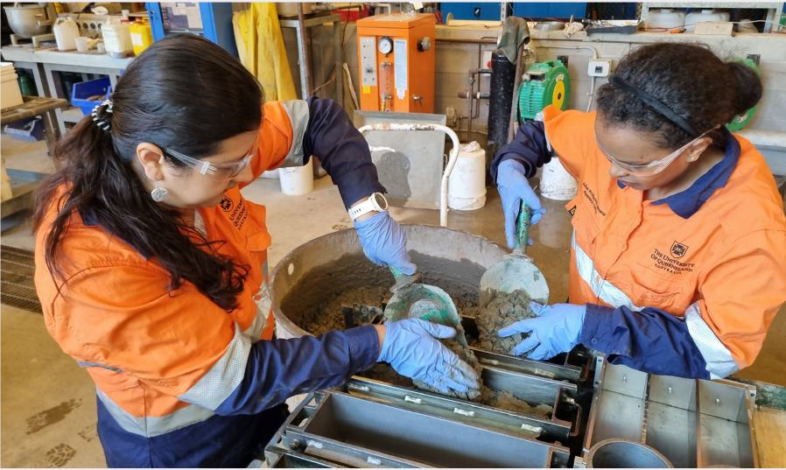UQ researchers are developing a sustainable alternative sand by extracting the unused silicate minerals in metal ores and transforming them into valuable by-products before they become waste. Sand is one of the most heavily mined commodities in the world and is essential to modern life, from construction and manufacturing to consumer products. Sand, gravel and crushed stone (known as aggregates) extraction can cause significant damage to ecosystems. At the same time, staggering amounts of waste from mining, such as tailings, are produced. This team is working to tackle these sand sustainability and mining waste problems with the same solution.

Lead Entrepreneur Dr Juliana Segura-Salazar (left) and project fellow Dr Lulit Habte Ekubatsion (right) at The University of Queensland’s School of Civil Engineering Concrete Laboratory at St Lucia.

## AEA Ignite Round 1

Ignite provides grant funding of up to $500,000 over 12 months for projects at the proof‑of‑concept stage (Technology Readiness Level 3–5). For the inaugural round launched in July 2024, the department received a total of 393 applications requesting over $143 million in funding.

Through Ignite Round 1, 154 grants were awarded for a total funding allocation of $59.1 million.

**Table 3: AEA Ignite Round 1 Outcomes**

|  |  |  |  |
| --- | --- | --- | --- |
|  | **Priority Area** | **Successful Proposals** | **Funding Awarded ($)** |
| 1 | Renewables and low emission technologies | 32 | 11,703,564.00 |
| 2 | Medical science | 46 | 18,587,649.00 |
| 3 | Value-add in agriculture, forestry, and fisheries sectors | 22 | 8,507,273.00 |
| 4 | Value-add in resources | 14 | 4,714,673.00 |
| 5 | Defence | 2 | 960,950.00 |
| 6 | Enabling Capabilities | 34 | 12,657,596.00 |
| 7 | Transport | 4 | 1,952,809.00 |
| **Total** |  | **154** | **59,084,514.00** |

**Table 4: Ignite grants by university**

|  |  |
| --- | --- |
| **University** | **Number of projects** |
| Australian Catholic University | 1 |
| Central Queensland University | 2 |
| Curtin University | 2 |
| Deakin University | 4 |
| Flinders University | 1 |
| Griffith University | 3 |
| James Cook University | 2 |
| La Trobe University | 3 |
| Macquarie University | 2 |
| Monash University | 7 |
| Queensland University of Technology | 8 |
| RMIT University | 11 |
| Swinburne University of Technology | 2 |
| The Australian National University | 7 |
| The University of New South Wales | 23 |
| The University of Newcastle | 2 |
| The University of Queensland | 12 |
| The University of Sydney | 10 |
| The University of Western Australia | 4 |
| The University of Adelaide | 7 |
| The University of Melbourne | 22 |
| University of Canberra | 1 |
| University of South Australia | 7 |
| University of Southern Queensland | 1 |
| University of Technology Sydney | 7 |
| University of the Sunshine Coast | 1 |
| University of Wollongong | 1 |
| Victoria University | 1 |
| **Total** | **154** |

## AEA Innovate Round 1

Innovate grants support mid-stage research commercialisation (Technology Readiness Level 5–7) through competitive grants of up to $5 million for a maximum period of 24 months. Innovate applications involve 2 steps as AEA Priority Managers provide applicants with feedback on an expression of interest (EOI) application prior to the submission of a full application. For the inaugural round launched in July 2024, the department received 91 EOI applications of which 62 progressed to a full application worth a total funding request of $155 million.

Through Innovate Round 1, 39 grants were awarded worth a total of $93.1 million.

## The Research Commercialisation Strategy

Under Section 42-1 of HESA, the Board is required by legislation to develop a 5-year research commercialisation strategy. The expert panel of the Strategic Examination of Research and Development (SERD) will report to Government in late 2025, and the Board will review its research commercialisation strategy in 2026 taking into account SERD recommendations and subsequent government commitments.

The strategy outlines the vision of AEA: to foster a culture of collaboration between universities and industry, catalysing public and private investment in the translation and commercialisation of research, increasing Australia’s sovereign capability, and creating a stronger and more complex Australian economy.

To meet the legislated requirement that the strategy is not inconsistent with Australia’s greenhouse gas emissions reduction targets, the Board has determined a number of technology focus areas to encourage applications that assist with the transition to the Australian Government’s legislated target of net zero by 2050. In particular, the sustainable fuels and renewable energy focus areas specifically address the Government’s Net Zero ambitions.

The strategy also sets out how the Board adapts their commercialisation focus areas as national priorities evolve over time.

Finally, the strategy outlines the Board’s direction on how AEA addresses the financial, cultural and regulatory barriers to commercialisation.

## The Investment Plan

As required under Section 42-5 of HESA, the Board must, in relation to each year, formulate written policies for the AEA program, dealing with the following matters in relation to the year:

a) areas of national priority

b) the total amount of funding available

c) any other matters the AEA Advisory Board considers appropriate to deal with to ensure the program meets the program’s objectives.

The Board has released its second investment plan for the financial year 2025–26. The plan states the amount of available AEA funding, the areas of national priority, and 8 focus areas that are highlighted for investment in 2025–26.

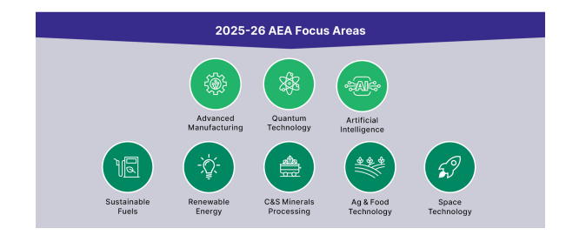**Figure 4. 2025-26 AEA focus areas**

The annual investment planning process ensures AEA remains agile and responsive to developments in the research and industry sectors and provides for transparency on the program’s direction.

The 2025–26 investment plan provides data for each area around research strength, research translation potential, market size, and strategic alignment with areas of national priority that have informed their selection.

**AEA Seed Cade Study**

**Sovereign Autonomous Underwater Vehicle**

**PRIORITY AREA > ENABLING CAPABILITIES**

**University of Sydney’s Sovereign Autonomous Underwater Vehicle capability initiative: $499,036**

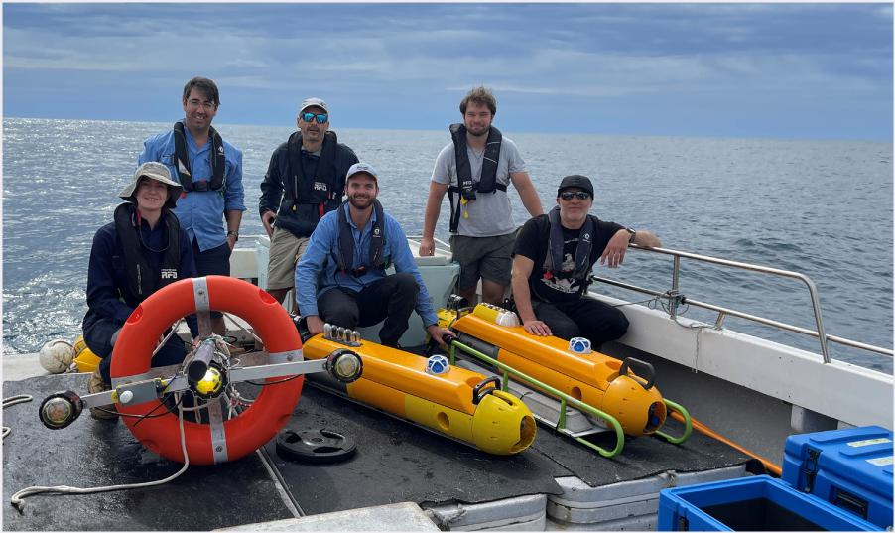Environmental impact assessments are crucial for offshore wind farms to identify, assess and mitigate potential environmental impacts, ensuring responsible development that balances renewable energy goals with marine ecosystem protection. Collecting environmental data to inform these assessments is often difficult because of the complexity of conditions on the seafloor. With the support of an AEA Seed grant, researchers from the University of Sydney have developed a sovereign Autonomous Underwater Vehicle (AUV) than can hover above the seafloor and collect this data.

Project lead Dr Lachlan Toohey’s team and their Industry partner Fathom Pacific, surveying seafloor sites near the Gippsland offshore wind area in Victoria.

## Barriers

The Board identified a number of barriers to increasing the translation and commercialisation of university research. After carefully considering the operations of AEA, the Board recommended the following changes to the program for 2025–26:

* Priority Managers will be domain experts, aligned to Government priorities and focus areas for investment
* Priority Managers will target the demand side of translation by engaging with investors, industry and end-users to identify opportunities for partnering with university researchers
* Priority Managers will broker relationships between university researchers and potential industry partners and investors
* Priority Managers will provide guidance to coach and mentor prospective applicants to build their confidence and capability
* The Board’s engagement plan will prioritise opportunities to link industry and investors with university researchers
* Targeted engagement with coaching programs will assist in building confidence, capability and participation in the program for female entrepreneurs, First Nations entrepreneurs, and regionally headquartered universities
* Introduction of a weighting system for AEA Ignite grants, supported by improved data collection, to boost applications from female entrepreneurs, First Nations entrepreneurs, and regionally headquartered universities

## Appendices

## Appendix A: Board member’s terms of appointment

|  |  |  |  |
| --- | --- | --- | --- |
| **Name** | **Role** | **Start date** | **End date** |
| Mr Jeff Connolly | Chair | 3 July 2024 | 2 July 2029 |
| Ms Julia Spicer OAM | Deputy Chair | 3 July 2024 | 2 July 2029 |
| Dr Angeline Achariya GAICD | Member | 3 July 2024 | 2 July 2029 |
| Prof Mark Hutchinson | Member | 3 July 2024 | 2 July 2027 |
| Dr Paul Kelly | Member | 3 July 2024 | 2 July 2027 |
| Dr Virginia Marshall | Member | 3 July 2024 | 2 July 2027 |
| Ms Catherine Roberts AO CSC | Member | 3 July 2024 | 2 July 2029 |
| Ms Lauren Stafford | Member | 3 July 2024 | 2 July 2027 |

Appendix B: Corrigendum

There was a typographical error made on page 16 of the [AEA Advisory Board 2023-24 Annual Report](https://www.aea.gov.au/resources/aea-advisory-boards-annual-report-2023-24) (https://www.aea.gov.au/resources/aea-advisory-boards-annual-report-2023-24). This section discussed the outcomes of the AEA Seed pilot program and inaccurately stated the funding awarded for the Enabling Capabilities priority area and by extension the total funding awarded for the Seed funding rounds. The text and table on the next page include the updated figures:

## AEA Seed

The pilot program, AEA Seed, was delivered through 3 separate rounds, with grants funded in each of the 7 Australian Government identified priority areas for the economy. The pilot was modelled on AEA Ignite and allowed for the testing of systems and processes ahead of the launch of the full AEA. The first funding round under the pilot opened in February 2023, the second round in March 2023, and the last round in December 2023.

Seed provided grant funding of up to $500,000 for projects over 12 months for projects at the proof‑of‑concept stage. Each round was oversubscribed, with a total of 498 applications requesting over $140 million in funding.

Through the pilot, 96 AEA seed projects received total funding allocation of $25.8 million.

Outcomes from the Seed funding rounds have been published on the [AEA website](https://www.aea.gov.au/) (<https://www.aea.gov.au>).

**Table 2. AEA Seed Outcomes (excludes withdrawn projects)**

|  |  |  |  |
| --- | --- | --- | --- |
|  | **Priority Area** | **Successful Proposals** | **Funding Awarded ($)** |
| 1 | Renewables and low emission technologies | 15 | 3,175,885.00 |
| 2 | Medical science | 18 | 4,457,213.00 |
| 3 | Value-add in agriculture, forestry, and fisheries sectors | 13 | 3,656,900.00 |
| 4 | Value-add in resources | 14 | 3,144,530.00 |
| 5 | Defence | 13 | 4,216,801.00 |
| 6 | Enabling Capabilities | 19 | 6,436,579.00 |
| 7 | Transport | 4 | 788,230.00 |
| **Total** |  | **96** | **25,876,138.00** |

1. The World Bank, Population, total [data set]., The World Bank, 2025, [Population, total – Australia, World | Data (worldbank.org)](https://data.worldbank.org/indicator/SP.POP.TOTL?locations=AU) (https://data.worldbank.org/indicator/SP.POP.TOTL?locations=AU-1W), accessed 2025.
2. Australian Bureau of Statistics (ABS), Research and Experimental Development, Higher Education Organisations, Australia, Australian Government, 2022, [ABS, Research and Experimental Development, Businesses, Higher Education Organisations](https://www.abs.gov.au/statistics/industry/technology-and-innovation/research-and-experimental-development-businesses-australia) (https://www.abs.gov.au/statistics/industry/technology-and-innovation/research-and-experimental-development-businesses-australia), accessed 2025, and Australian Bureau of Statistics (ABS), Research and Experimental Development, Government and Private Non-Profit Organisations, Australia, Australian Government, 2022 [Research and Experimental Development, Government and Private Non-Profit Organisations](https://www.abs.gov.au/statistics/industry/technology-and-innovation/research-and-experimental-development-government-and-private-non-profit-organisations-australia/latest-release) (https://www.abs.gov. au/statistics/industry/technology-and-innovation/research-and-experimental-development-government-and-private-non-profit-organisations-australia/latest-release), accessed 2025.
3. Department of Industry, Science and Resources (DISER), Strategic Examination of Research and Development: discussion paper, Australian Government, 2025, <https://consult.industry.gov.au/strategic-examination-rd-discussion-paper>, accessed 2025.
4. OECD, The Atlas of Economic Complexity, OECD 2024, [The Atlas of Economic Complexity](https://atlas.hks.harvard.edu/) (https://atlas.hks.harvard.edu/), accessed 2024.
5. OECD, Business innovation statistics and indicators, OECD 2023, [Business innovation statistics and indicators | OECD](https://www.oecd.org/en/data/datasets/business-innovation-statistics-and-indicators.html) (https://www.oecd.org/sti/inno/inno-stats.htm), accessed 2025.
6. Department of Education, Research Translation and Commercialisation Agenda, Australian Government 2024 [Research Translation and Commercialisation Agenda - Department of Education, Australian Government](https://www.education.gov.au/research-translation-and-commercialisation-agenda), (https://www.education.gov.au/research-translation-and-commercialisation-agenda) accessed 2025.
7. Department of Industry, Science and Resources (DISER), Strategic Examination of Research and Development: discussion paper, Australian Government, 2025, [Science, research and innovation (SRI) budget tables | Department of Industry Science and Resources](https://www.industry.gov.au/publications/science-research-and-innovation-sri-budget-tables) (https://www.industry.gov.au/publications/science-research-and-innovation-sri-budget-tables), accessed 2025